Screenshots of outputs

**DataFrame Shape**

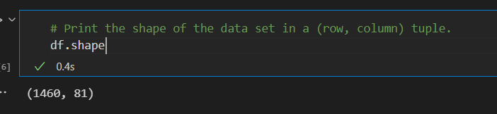

**DataFrame Null Values**

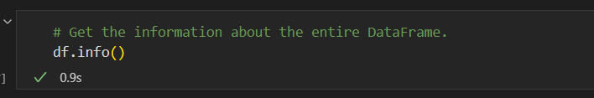

<class 'pandas.core.frame.DataFrame'>

RangeIndex: 1460 entries, 0 to 1459

Data columns (total 81 columns):

# Column Non-Null Count Dtype

--- ------ -------------- -----

0 Id 1460 non-null int64

1 MSSubClass 1460 non-null int64

2 MSZoning 1460 non-null object

3 LotFrontage 1201 non-null float64

4 LotArea 1460 non-null int64

5 Street 1460 non-null object

6 Alley 91 non-null object

7 LotShape 1460 non-null object

8 LandContour 1460 non-null object

9 Utilities 1460 non-null object

10 LotConfig 1460 non-null object

11 LandSlope 1460 non-null object

12 Neighborhood 1460 non-null object

13 Condition1 1460 non-null object

14 Condition2 1460 non-null object

15 BldgType 1460 non-null object

16 HouseStyle 1460 non-null object

17 OverallQual 1460 non-null int64

18 OverallCond 1460 non-null int64

19 YearBuilt 1460 non-null int64

20 YearRemodAdd 1460 non-null int64

21 RoofStyle 1460 non-null object

22 RoofMatl 1460 non-null object

23 Exterior1st 1460 non-null object

24 Exterior2nd 1460 non-null object

25 MasVnrType 1452 non-null object

26 MasVnrArea 1452 non-null float64

27 ExterQual 1460 non-null object

28 ExterCond 1460 non-null object

29 Foundation 1460 non-null object

30 BsmtQual 1423 non-null object

31 BsmtCond 1423 non-null object

32 BsmtExposure 1422 non-null object

33 BsmtFinType1 1423 non-null object

34 BsmtFinSF1 1460 non-null int64

35 BsmtFinType2 1422 non-null object

36 BsmtFinSF2 1460 non-null int64

37 BsmtUnfSF 1460 non-null int64

38 TotalBsmtSF 1460 non-null int64

39 Heating 1460 non-null object

40 HeatingQC 1460 non-null object

41 CentralAir 1460 non-null object

42 Electrical 1459 non-null object

43 1stFlrSF 1460 non-null int64

44 2ndFlrSF 1460 non-null int64

45 LowQualFinSF 1460 non-null int64

46 GrLivArea 1460 non-null int64

47 BsmtFullBath 1460 non-null int64

48 BsmtHalfBath 1460 non-null int64

49 FullBath 1460 non-null int64

50 HalfBath 1460 non-null int64

51 BedroomAbvGr 1460 non-null int64

52 KitchebvGr 1460 non-null int64

53 KitchenQual 1460 non-null object

54 TotRmsAbvGrd 1460 non-null int64

55 Functiol 1460 non-null object

56 Fireplaces 1460 non-null int64

57 FireplaceQu 770 non-null object

58 GarageType 1379 non-null object

59 GarageYrBlt 1379 non-null float64

60 GarageFinish 1379 non-null object

61 GarageCars 1460 non-null int64

62 GarageArea 1460 non-null int64

63 GarageQual 1379 non-null object

64 GarageCond 1379 non-null object

65 PavedDrive 1460 non-null object

66 WoodDeckSF 1460 non-null int64

67 OpenPorchSF 1460 non-null int64

68 EnclosedPorch 1460 non-null int64

69 3SsnPorch 1460 non-null int64

70 ScreenPorch 1460 non-null int64

71 PoolArea 1460 non-null int64

72 PoolQC 7 non-null object

73 Fence 281 non-null object

74 MiscFeature 54 non-null object

75 MiscVal 1460 non-null int64

76 MoSold 1460 non-null int64

77 YrSold 1460 non-null int64

78 SaleType 1460 non-null object

79 SaleCondition 1460 non-null object

80 SalePrice 1460 non-null int64

dtypes: float64(3), int64(35), object(43)

memory usage: 924.0+ KB

**Alternatively**

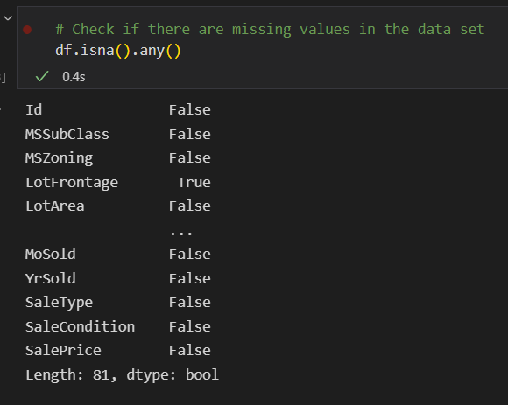

**DataFrame Unique Values**

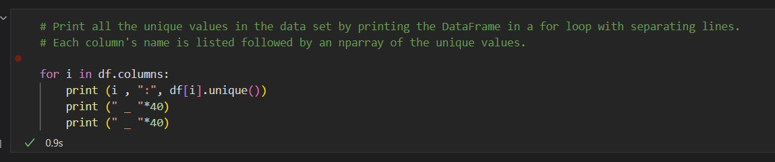

Id : [ 1 2 3 ... 1458 1459 1460]

_ _ _ _ _ _ _ _ _ _ _ _ _ _ _ _ _ _ _ _ _ _ _ _ _ _ _ _ _ _ _ _ _ _ _ _ _ _ _ _

_ _ _ _ _ _ _ _ _ _ _ _ _ _ _ _ _ _ _ _ _ _ _ _ _ _ _ _ _ _ _ _ _ _ _ _ _ _ _ _

MSSubClass : [ 60 20 70 50 190 45 90 120 30 85 80 160 75 180 40]

_ _ _ _ _ _ _ _ _ _ _ _ _ _ _ _ _ _ _ _ _ _ _ _ _ _ _ _ _ _ _ _ _ _ _ _ _ _ _ _

_ _ _ _ _ _ _ _ _ _ _ _ _ _ _ _ _ _ _ _ _ _ _ _ _ _ _ _ _ _ _ _ _ _ _ _ _ _ _ _

MSZoning : ['RL' 'RM' 'C (all)' 'FV' 'RH']

_ _ _ _ _ _ _ _ _ _ _ _ _ _ _ _ _ _ _ _ _ _ _ _ _ _ _ _ _ _ _ _ _ _ _ _ _ _ _ _

_ _ _ _ _ _ _ _ _ _ _ _ _ _ _ _ _ _ _ _ _ _ _ _ _ _ _ _ _ _ _ _ _ _ _ _ _ _ _ _

LotFrontage : [ 65. 80. 68. 60. 84. 85. 75. nan 51. 50. 70. 91. 72. 66.

101. 57. 44. 110. 98. 47. 108. 112. 74. 115. 61. 48. 33. 52.

100. 24. 89. 63. 76. 81. 95. 69. 21. 32. 78. 121. 122. 40.

105. 73. 77. 64. 94. 34. 90. 55. 88. 82. 71. 120. 107. 92.

134. 62. 86. 141. 97. 54. 41. 79. 174. 99. 67. 83. 43. 103.

93. 30. 129. 140. 35. 37. 118. 87. 116. 150. 111. 49. 96. 59.

36. 56. 102. 58. 38. 109. 130. 53. 137. 45. 106. 104. 42. 39.

144. 114. 128. 149. 313. 168. 182. 138. 160. 152. 124. 153. 46.]

_ _ _ _ _ _ _ _ _ _ _ _ _ _ _ _ _ _ _ _ _ _ _ _ _ _ _ _ _ _ _ _ _ _ _ _ _ _ _ _

_ _ _ _ _ _ _ _ _ _ _ _ _ _ _ _ _ _ _ _ _ _ _ _ _ _ _ _ _ _ _ _ _ _ _ _ _ _ _ _

LotArea : [ 8450 9600 11250 ... 17217 13175 9717]

_ _ _ _ _ _ _ _ _ _ _ _ _ _ _ _ _ _ _ _ _ _ _ _ _ _ _ _ _ _ _ _ _ _ _ _ _ _ _ _

_ _ _ _ _ _ _ _ _ _ _ _ _ _ _ _ _ _ _ _ _ _ _ _ _ _ _ _ _ _ _ _ _ _ _ _ _ _ _ _

Street : ['Pave' 'Grvl']

_ _ _ _ _ _ _ _ _ _ _ _ _ _ _ _ _ _ _ _ _ _ _ _ _ _ _ _ _ _ _ _ _ _ _ _ _ _ _ _

_ _ _ _ _ _ _ _ _ _ _ _ _ _ _ _ _ _ _ _ _ _ _ _ _ _ _ _ _ _ _ _ _ _ _ _ _ _ _ _

Alley : [nan 'Grvl' 'Pave']

_ _ _ _ _ _ _ _ _ _ _ _ _ _ _ _ _ _ _ _ _ _ _ _ _ _ _ _ _ _ _ _ _ _ _ _ _ _ _ _

_ _ _ _ _ _ _ _ _ _ _ _ _ _ _ _ _ _ _ _ _ _ _ _ _ _ _ _ _ _ _ _ _ _ _ _ _ _ _ _

LotShape : ['Reg' 'IR1' 'IR2' 'IR3']

_ _ _ _ _ _ _ _ _ _ _ _ _ _ _ _ _ _ _ _ _ _ _ _ _ _ _ _ _ _ _ _ _ _ _ _ _ _ _ _

_ _ _ _ _ _ _ _ _ _ _ _ _ _ _ _ _ _ _ _ _ _ _ _ _ _ _ _ _ _ _ _ _ _ _ _ _ _ _ _

LandContour : ['Lvl' 'Bnk' 'Low' 'HLS']

_ _ _ _ _ _ _ _ _ _ _ _ _ _ _ _ _ _ _ _ _ _ _ _ _ _ _ _ _ _ _ _ _ _ _ _ _ _ _ _

_ _ _ _ _ _ _ _ _ _ _ _ _ _ _ _ _ _ _ _ _ _ _ _ _ _ _ _ _ _ _ _ _ _ _ _ _ _ _ _

Utilities : ['AllPub' 'NoSeWa']

_ _ _ _ _ _ _ _ _ _ _ _ _ _ _ _ _ _ _ _ _ _ _ _ _ _ _ _ _ _ _ _ _ _ _ _ _ _ _ _

_ _ _ _ _ _ _ _ _ _ _ _ _ _ _ _ _ _ _ _ _ _ _ _ _ _ _ _ _ _ _ _ _ _ _ _ _ _ _ _

LotConfig : ['Inside' 'FR2' 'Corner' 'CulDSac' 'FR3']

_ _ _ _ _ _ _ _ _ _ _ _ _ _ _ _ _ _ _ _ _ _ _ _ _ _ _ _ _ _ _ _ _ _ _ _ _ _ _ _

_ _ _ _ _ _ _ _ _ _ _ _ _ _ _ _ _ _ _ _ _ _ _ _ _ _ _ _ _ _ _ _ _ _ _ _ _ _ _ _

LandSlope : ['Gtl' 'Mod' 'Sev']

_ _ _ _ _ _ _ _ _ _ _ _ _ _ _ _ _ _ _ _ _ _ _ _ _ _ _ _ _ _ _ _ _ _ _ _ _ _ _ _

_ _ _ _ _ _ _ _ _ _ _ _ _ _ _ _ _ _ _ _ _ _ _ _ _ _ _ _ _ _ _ _ _ _ _ _ _ _ _ _

Neighborhood : ['CollgCr' 'Veenker' 'Crawfor' 'NoRidge' 'Mitchel' 'Somerst' 'NWAmes'

'OldTown' 'BrkSide' 'Sawyer' 'NridgHt' 'mes' 'SawyerW' 'IDOTRR' 'MeadowV'

'Edwards' 'Timber' 'Gilbert' 'StoneBr' 'ClearCr' 'NPkVill' 'Blmngtn'

'BrDale' 'SWISU' 'Blueste']

_ _ _ _ _ _ _ _ _ _ _ _ _ _ _ _ _ _ _ _ _ _ _ _ _ _ _ _ _ _ _ _ _ _ _ _ _ _ _ _

_ _ _ _ _ _ _ _ _ _ _ _ _ _ _ _ _ _ _ _ _ _ _ _ _ _ _ _ _ _ _ _ _ _ _ _ _ _ _ _

Condition1 : ['Norm' 'Feedr' 'PosN' 'Artery' 'RRAe' 'RRNn' 'RRAn' 'PosA' 'RRNe']

_ _ _ _ _ _ _ _ _ _ _ _ _ _ _ _ _ _ _ _ _ _ _ _ _ _ _ _ _ _ _ _ _ _ _ _ _ _ _ _

_ _ _ _ _ _ _ _ _ _ _ _ _ _ _ _ _ _ _ _ _ _ _ _ _ _ _ _ _ _ _ _ _ _ _ _ _ _ _ _

Condition2 : ['Norm' 'Artery' 'RRNn' 'Feedr' 'PosN' 'PosA' 'RRAn' 'RRAe']

_ _ _ _ _ _ _ _ _ _ _ _ _ _ _ _ _ _ _ _ _ _ _ _ _ _ _ _ _ _ _ _ _ _ _ _ _ _ _ _

_ _ _ _ _ _ _ _ _ _ _ _ _ _ _ _ _ _ _ _ _ _ _ _ _ _ _ _ _ _ _ _ _ _ _ _ _ _ _ _

BldgType : ['1Fam' '2fmCon' 'Duplex' 'TwnhsE' 'Twnhs']

_ _ _ _ _ _ _ _ _ _ _ _ _ _ _ _ _ _ _ _ _ _ _ _ _ _ _ _ _ _ _ _ _ _ _ _ _ _ _ _

_ _ _ _ _ _ _ _ _ _ _ _ _ _ _ _ _ _ _ _ _ _ _ _ _ _ _ _ _ _ _ _ _ _ _ _ _ _ _ _

HouseStyle : ['2Story' '1Story' '1.5Fin' '1.5Unf' 'SFoyer' 'SLvl' '2.5Unf' '2.5Fin']

_ _ _ _ _ _ _ _ _ _ _ _ _ _ _ _ _ _ _ _ _ _ _ _ _ _ _ _ _ _ _ _ _ _ _ _ _ _ _ _

_ _ _ _ _ _ _ _ _ _ _ _ _ _ _ _ _ _ _ _ _ _ _ _ _ _ _ _ _ _ _ _ _ _ _ _ _ _ _ _

OverallQual : [ 7 6 8 5 9 4 10 3 1 2]

_ _ _ _ _ _ _ _ _ _ _ _ _ _ _ _ _ _ _ _ _ _ _ _ _ _ _ _ _ _ _ _ _ _ _ _ _ _ _ _

_ _ _ _ _ _ _ _ _ _ _ _ _ _ _ _ _ _ _ _ _ _ _ _ _ _ _ _ _ _ _ _ _ _ _ _ _ _ _ _

OverallCond : [5 8 6 7 4 2 3 9 1]

_ _ _ _ _ _ _ _ _ _ _ _ _ _ _ _ _ _ _ _ _ _ _ _ _ _ _ _ _ _ _ _ _ _ _ _ _ _ _ _

_ _ _ _ _ _ _ _ _ _ _ _ _ _ _ _ _ _ _ _ _ _ _ _ _ _ _ _ _ _ _ _ _ _ _ _ _ _ _ _

YearBuilt : [2003 1976 2001 1915 2000 1993 2004 1973 1931 1939 1965 2005 1962 2006

1960 1929 1970 1967 1958 1930 2002 1968 2007 1951 1957 1927 1920 1966

1959 1994 1954 1953 1955 1983 1975 1997 1934 1963 1981 1964 1999 1972

1921 1945 1982 1998 1956 1948 1910 1995 1991 2009 1950 1961 1977 1985

1979 1885 1919 1990 1969 1935 1988 1971 1952 1936 1923 1924 1984 1926

1940 1941 1987 1986 2008 1908 1892 1916 1932 1918 1912 1947 1925 1900

1980 1989 1992 1949 1880 1928 1978 1922 1996 2010 1946 1913 1937 1942

1938 1974 1893 1914 1906 1890 1898 1904 1882 1875 1911 1917 1872 1905]

_ _ _ _ _ _ _ _ _ _ _ _ _ _ _ _ _ _ _ _ _ _ _ _ _ _ _ _ _ _ _ _ _ _ _ _ _ _ _ _

_ _ _ _ _ _ _ _ _ _ _ _ _ _ _ _ _ _ _ _ _ _ _ _ _ _ _ _ _ _ _ _ _ _ _ _ _ _ _ _

YearRemodAdd : [2003 1976 2002 1970 2000 1995 2005 1973 1950 1965 2006 1962 2007 1960

2001 1967 2004 2008 1997 1959 1990 1955 1983 1980 1966 1963 1987 1964

1972 1996 1998 1989 1953 1956 1968 1981 1992 2009 1982 1961 1993 1999

1985 1979 1977 1969 1958 1991 1971 1952 1975 2010 1984 1986 1994 1988

1954 1957 1951 1978 1974]

_ _ _ _ _ _ _ _ _ _ _ _ _ _ _ _ _ _ _ _ _ _ _ _ _ _ _ _ _ _ _ _ _ _ _ _ _ _ _ _

_ _ _ _ _ _ _ _ _ _ _ _ _ _ _ _ _ _ _ _ _ _ _ _ _ _ _ _ _ _ _ _ _ _ _ _ _ _ _ _

RoofStyle : ['Gable' 'Hip' 'Gambrel' 'Mansard' 'Flat' 'Shed']

_ _ _ _ _ _ _ _ _ _ _ _ _ _ _ _ _ _ _ _ _ _ _ _ _ _ _ _ _ _ _ _ _ _ _ _ _ _ _ _

_ _ _ _ _ _ _ _ _ _ _ _ _ _ _ _ _ _ _ _ _ _ _ _ _ _ _ _ _ _ _ _ _ _ _ _ _ _ _ _

RoofMatl : ['CompShg' 'WdShngl' 'Metal' 'WdShake' 'Membran' 'Tar&Grv' 'Roll'

'ClyTile']

_ _ _ _ _ _ _ _ _ _ _ _ _ _ _ _ _ _ _ _ _ _ _ _ _ _ _ _ _ _ _ _ _ _ _ _ _ _ _ _

_ _ _ _ _ _ _ _ _ _ _ _ _ _ _ _ _ _ _ _ _ _ _ _ _ _ _ _ _ _ _ _ _ _ _ _ _ _ _ _

Exterior1st : ['VinylSd' 'MetalSd' 'Wd Sdng' 'HdBoard' 'BrkFace' 'WdShing' 'CemntBd'

'Plywood' 'AsbShng' 'Stucco' 'BrkComm' 'AsphShn' 'Stone' 'ImStucc'

'CBlock']

_ _ _ _ _ _ _ _ _ _ _ _ _ _ _ _ _ _ _ _ _ _ _ _ _ _ _ _ _ _ _ _ _ _ _ _ _ _ _ _

_ _ _ _ _ _ _ _ _ _ _ _ _ _ _ _ _ _ _ _ _ _ _ _ _ _ _ _ _ _ _ _ _ _ _ _ _ _ _ _

Exterior2nd : ['VinylSd' 'MetalSd' 'Wd Shng' 'HdBoard' 'Plywood' 'Wd Sdng' 'CmentBd'

'BrkFace' 'Stucco' 'AsbShng' 'Brk Cmn' 'ImStucc' 'AsphShn' 'Stone'

'Other' 'CBlock']

_ _ _ _ _ _ _ _ _ _ _ _ _ _ _ _ _ _ _ _ _ _ _ _ _ _ _ _ _ _ _ _ _ _ _ _ _ _ _ _

_ _ _ _ _ _ _ _ _ _ _ _ _ _ _ _ _ _ _ _ _ _ _ _ _ _ _ _ _ _ _ _ _ _ _ _ _ _ _ _

MasVnrType : ['BrkFace' 'None' 'Stone' 'BrkCmn' nan]

_ _ _ _ _ _ _ _ _ _ _ _ _ _ _ _ _ _ _ _ _ _ _ _ _ _ _ _ _ _ _ _ _ _ _ _ _ _ _ _

_ _ _ _ _ _ _ _ _ _ _ _ _ _ _ _ _ _ _ _ _ _ _ _ _ _ _ _ _ _ _ _ _ _ _ _ _ _ _ _

MasVnrArea : [1.960e+02 0.000e+00 1.620e+02 3.500e+02 1.860e+02 2.400e+02 2.860e+02

3.060e+02 2.120e+02 1.800e+02 3.800e+02 2.810e+02 6.400e+02 2.000e+02

2.460e+02 1.320e+02 6.500e+02 1.010e+02 4.120e+02 2.720e+02 4.560e+02

1.031e+03 1.780e+02 5.730e+02 3.440e+02 2.870e+02 1.670e+02 1.115e+03

4.000e+01 1.040e+02 5.760e+02 4.430e+02 4.680e+02 6.600e+01 2.200e+01

2.840e+02 7.600e+01 2.030e+02 6.800e+01 1.830e+02 4.800e+01 2.800e+01

3.360e+02 6.000e+02 7.680e+02 4.800e+02 2.200e+02 1.840e+02 1.129e+03

1.160e+02 1.350e+02 2.660e+02 8.500e+01 3.090e+02 1.360e+02 2.880e+02

7.000e+01 3.200e+02 5.000e+01 1.200e+02 4.360e+02 2.520e+02 8.400e+01

6.640e+02 2.260e+02 3.000e+02 6.530e+02 1.120e+02 4.910e+02 2.680e+02

7.480e+02 9.800e+01 2.750e+02 1.380e+02 2.050e+02 2.620e+02 1.280e+02

2.600e+02 1.530e+02 6.400e+01 3.120e+02 1.600e+01 9.220e+02 1.420e+02

2.900e+02 1.270e+02 5.060e+02 2.970e+02 nan 6.040e+02 2.540e+02

3.600e+01 1.020e+02 4.720e+02 4.810e+02 1.080e+02 3.020e+02 1.720e+02

3.990e+02 2.700e+02 4.600e+01 2.100e+02 1.740e+02 3.480e+02 3.150e+02

2.990e+02 3.400e+02 1.660e+02 7.200e+01 3.100e+01 3.400e+01 2.380e+02

1.600e+03 3.650e+02 5.600e+01 1.500e+02 2.780e+02 2.560e+02 2.250e+02

3.700e+02 3.880e+02 1.750e+02 2.960e+02 1.460e+02 1.130e+02 1.760e+02

6.160e+02 3.000e+01 1.060e+02 8.700e+02 3.620e+02 5.300e+02 5.000e+02

5.100e+02 2.470e+02 3.050e+02 2.550e+02 1.250e+02 1.000e+02 4.320e+02

1.260e+02 4.730e+02 7.400e+01 1.450e+02 2.320e+02 3.760e+02 4.200e+01

1.610e+02 1.100e+02 1.800e+01 2.240e+02 2.480e+02 8.000e+01 3.040e+02

2.150e+02 7.720e+02 4.350e+02 3.780e+02 5.620e+02 1.680e+02 8.900e+01

2.850e+02 3.600e+02 9.400e+01 3.330e+02 9.210e+02 7.620e+02 5.940e+02

2.190e+02 1.880e+02 4.790e+02 5.840e+02 1.820e+02 2.500e+02 2.920e+02

2.450e+02 2.070e+02 8.200e+01 9.700e+01 3.350e+02 2.080e+02 4.200e+02

1.700e+02 4.590e+02 2.800e+02 9.900e+01 1.920e+02 2.040e+02 2.330e+02

1.560e+02 4.520e+02 5.130e+02 2.610e+02 1.640e+02 2.590e+02 2.090e+02

2.630e+02 2.160e+02 3.510e+02 6.600e+02 3.810e+02 5.400e+01 5.280e+02

2.580e+02 4.640e+02 5.700e+01 1.470e+02 1.170e+03 2.930e+02 6.300e+02

4.660e+02 1.090e+02 4.100e+01 1.600e+02 2.890e+02 6.510e+02 1.690e+02

9.500e+01 4.420e+02 2.020e+02 3.380e+02 8.940e+02 3.280e+02 6.730e+02

6.030e+02 1.000e+00 3.750e+02 9.000e+01 3.800e+01 1.570e+02 1.100e+01

1.400e+02 1.300e+02 1.480e+02 8.600e+02 4.240e+02 1.047e+03 2.430e+02

8.160e+02 3.870e+02 2.230e+02 1.580e+02 1.370e+02 1.150e+02 1.890e+02

2.740e+02 1.170e+02 6.000e+01 1.220e+02 9.200e+01 4.150e+02 7.600e+02

2.700e+01 7.500e+01 3.610e+02 1.050e+02 3.420e+02 2.980e+02 5.410e+02

2.360e+02 1.440e+02 4.230e+02 4.400e+01 1.510e+02 9.750e+02 4.500e+02

2.300e+02 5.710e+02 2.400e+01 5.300e+01 2.060e+02 1.400e+01 3.240e+02

2.950e+02 3.960e+02 6.700e+01 1.540e+02 4.250e+02 4.500e+01 1.378e+03

3.370e+02 1.490e+02 1.430e+02 5.100e+01 1.710e+02 2.340e+02 6.300e+01

7.660e+02 3.200e+01 8.100e+01 1.630e+02 5.540e+02 2.180e+02 6.320e+02

1.140e+02 5.670e+02 3.590e+02 4.510e+02 6.210e+02 7.880e+02 8.600e+01

7.960e+02 3.910e+02 2.280e+02 8.800e+01 1.650e+02 4.280e+02 4.100e+02

5.640e+02 3.680e+02 3.180e+02 5.790e+02 6.500e+01 7.050e+02 4.080e+02

2.440e+02 1.230e+02 3.660e+02 7.310e+02 4.480e+02 2.940e+02 3.100e+02

2.370e+02 4.260e+02 9.600e+01 4.380e+02 1.940e+02 1.190e+02]

_ _ _ _ _ _ _ _ _ _ _ _ _ _ _ _ _ _ _ _ _ _ _ _ _ _ _ _ _ _ _ _ _ _ _ _ _ _ _ _

_ _ _ _ _ _ _ _ _ _ _ _ _ _ _ _ _ _ _ _ _ _ _ _ _ _ _ _ _ _ _ _ _ _ _ _ _ _ _ _

ExterQual : ['Gd' 'TA' 'Ex' 'Fa']

_ _ _ _ _ _ _ _ _ _ _ _ _ _ _ _ _ _ _ _ _ _ _ _ _ _ _ _ _ _ _ _ _ _ _ _ _ _ _ _

_ _ _ _ _ _ _ _ _ _ _ _ _ _ _ _ _ _ _ _ _ _ _ _ _ _ _ _ _ _ _ _ _ _ _ _ _ _ _ _

ExterCond : ['TA' 'Gd' 'Fa' 'Po' 'Ex']

_ _ _ _ _ _ _ _ _ _ _ _ _ _ _ _ _ _ _ _ _ _ _ _ _ _ _ _ _ _ _ _ _ _ _ _ _ _ _ _

_ _ _ _ _ _ _ _ _ _ _ _ _ _ _ _ _ _ _ _ _ _ _ _ _ _ _ _ _ _ _ _ _ _ _ _ _ _ _ _

Foundation : ['PConc' 'CBlock' 'BrkTil' 'Wood' 'Slab' 'Stone']

_ _ _ _ _ _ _ _ _ _ _ _ _ _ _ _ _ _ _ _ _ _ _ _ _ _ _ _ _ _ _ _ _ _ _ _ _ _ _ _

_ _ _ _ _ _ _ _ _ _ _ _ _ _ _ _ _ _ _ _ _ _ _ _ _ _ _ _ _ _ _ _ _ _ _ _ _ _ _ _

BsmtQual : ['Gd' 'TA' 'Ex' nan 'Fa']

_ _ _ _ _ _ _ _ _ _ _ _ _ _ _ _ _ _ _ _ _ _ _ _ _ _ _ _ _ _ _ _ _ _ _ _ _ _ _ _

_ _ _ _ _ _ _ _ _ _ _ _ _ _ _ _ _ _ _ _ _ _ _ _ _ _ _ _ _ _ _ _ _ _ _ _ _ _ _ _

BsmtCond : ['TA' 'Gd' nan 'Fa' 'Po']

_ _ _ _ _ _ _ _ _ _ _ _ _ _ _ _ _ _ _ _ _ _ _ _ _ _ _ _ _ _ _ _ _ _ _ _ _ _ _ _

_ _ _ _ _ _ _ _ _ _ _ _ _ _ _ _ _ _ _ _ _ _ _ _ _ _ _ _ _ _ _ _ _ _ _ _ _ _ _ _

BsmtExposure : ['No' 'Gd' 'Mn' 'Av' nan]

_ _ _ _ _ _ _ _ _ _ _ _ _ _ _ _ _ _ _ _ _ _ _ _ _ _ _ _ _ _ _ _ _ _ _ _ _ _ _ _

_ _ _ _ _ _ _ _ _ _ _ _ _ _ _ _ _ _ _ _ _ _ _ _ _ _ _ _ _ _ _ _ _ _ _ _ _ _ _ _

BsmtFinType1 : ['GLQ' 'ALQ' 'Unf' 'Rec' 'BLQ' nan 'LwQ']

_ _ _ _ _ _ _ _ _ _ _ _ _ _ _ _ _ _ _ _ _ _ _ _ _ _ _ _ _ _ _ _ _ _ _ _ _ _ _ _

_ _ _ _ _ _ _ _ _ _ _ _ _ _ _ _ _ _ _ _ _ _ _ _ _ _ _ _ _ _ _ _ _ _ _ _ _ _ _ _

BsmtFinSF1 : [ 706 978 486 216 655 732 1369 859 0 851 906 998 737 733

578 646 504 840 188 234 1218 1277 1018 1153 1213 731 643 967

747 280 179 456 1351 24 763 182 104 1810 384 490 649 632

941 739 912 1013 603 1880 565 320 462 228 336 448 1201 33

588 600 713 1046 648 310 1162 520 108 569 1200 224 705 444

250 984 35 774 419 170 1470 938 570 300 120 116 512 567

445 695 405 1005 668 821 432 1300 507 679 1332 209 680 716

1400 416 429 222 57 660 1016 370 351 379 1288 360 639 495

288 1398 477 831 1904 436 352 611 1086 297 626 560 390 566

1126 1036 1088 641 617 662 312 1065 787 468 36 822 378 946

341 16 550 524 56 321 842 689 625 358 402 94 1078 329

929 697 1573 270 922 503 1334 361 672 506 714 403 751 226

620 546 392 421 905 904 430 614 450 210 292 795 1285 819

420 841 281 894 1464 700 262 1274 518 1236 425 692 987 970

28 256 1619 40 846 1124 720 828 1249 810 213 585 129 498

1270 573 1410 1082 236 388 334 874 956 773 399 162 712 609

371 540 72 623 428 350 298 1445 218 985 631 1280 241 690

266 777 812 786 1116 789 1056 50 1128 775 1309 1246 986 616

1518 664 387 471 385 365 1767 133 642 247 331 742 1606 916

185 544 553 326 778 386 426 368 459 1350 1196 630 994 168

1261 1567 299 897 607 836 515 374 1231 111 356 400 698 1247

257 380 27 141 991 650 521 1436 2260 719 377 1330 348 1219

783 969 673 1358 1260 144 584 554 1002 619 180 559 308 866

895 637 604 1302 1071 290 728 2 1441 943 231 414 349 442

328 594 816 1460 1324 1338 685 1422 1283 81 454 903 605 990

206 150 457 48 871 41 674 624 480 1154 738 493 1121 282

500 131 1696 806 1361 920 1721 187 1138 988 193 551 767 1186

892 311 827 543 1003 1059 239 945 20 1455 965 980 863 533

1084 1173 523 1148 191 1234 375 808 724 152 1180 252 832 575

919 439 381 438 549 612 1163 437 394 1416 422 762 975 1097

251 686 656 568 539 862 197 516 663 608 1636 784 249 1040

483 196 572 338 330 156 1390 513 460 659 364 564 306 505

932 750 64 633 1170 899 902 1238 528 1024 1064 285 2188 465

322 860 599 354 63 223 301 443 489 284 294 814 165 552

833 464 936 772 1440 748 982 398 562 484 417 699 696 896

556 1106 651 867 854 1646 1074 536 1172 915 595 1237 273 684

324 1165 138 1513 317 1012 1022 509 900 1085 1104 240 383 644

397 740 837 220 586 535 410 75 824 592 1039 510 423 661

248 704 412 1032 219 708 415 1004 353 702 369 622 212 645

852 1150 1258 275 176 296 538 1157 492 1198 1387 522 658 1216

1480 2096 1159 440 1456 883 547 788 485 340 1220 427 344 756

1540 666 803 1000 885 1386 319 534 125 1314 602 192 593 804

1053 532 1158 1014 194 167 776 5644 694 1572 746 1406 925 482

189 765 80 1443 259 735 734 1447 548 315 1282 408 309 203

865 204 790 1320 769 1070 264 759 1373 976 781 25 1110 404

580 678 958 1336 1079 49 830]

_ _ _ _ _ _ _ _ _ _ _ _ _ _ _ _ _ _ _ _ _ _ _ _ _ _ _ _ _ _ _ _ _ _ _ _ _ _ _ _

_ _ _ _ _ _ _ _ _ _ _ _ _ _ _ _ _ _ _ _ _ _ _ _ _ _ _ _ _ _ _ _ _ _ _ _ _ _ _ _

BsmtFinType2 : ['Unf' 'BLQ' nan 'ALQ' 'Rec' 'LwQ' 'GLQ']

_ _ _ _ _ _ _ _ _ _ _ _ _ _ _ _ _ _ _ _ _ _ _ _ _ _ _ _ _ _ _ _ _ _ _ _ _ _ _ _

_ _ _ _ _ _ _ _ _ _ _ _ _ _ _ _ _ _ _ _ _ _ _ _ _ _ _ _ _ _ _ _ _ _ _ _ _ _ _ _

BsmtFinSF2 : [ 0 32 668 486 93 491 506 712 362 41 169 869 150 670

28 1080 181 768 215 374 208 441 184 279 306 180 580 690

692 228 125 1063 620 175 820 1474 264 479 147 232 380 544

294 258 121 391 531 344 539 713 210 311 1120 165 532 96

495 174 1127 139 202 645 123 551 219 606 612 480 182 132

336 468 287 35 499 723 119 40 117 239 80 472 64 1057

127 630 128 377 764 345 1085 435 823 500 290 324 634 411

841 1061 466 396 354 149 193 273 465 400 682 557 230 106

791 240 547 469 177 108 600 492 211 168 1031 438 375 144

81 906 608 276 661 68 173 972 105 420 546 334 352 872

110 627 163 1029]

_ _ _ _ _ _ _ _ _ _ _ _ _ _ _ _ _ _ _ _ _ _ _ _ _ _ _ _ _ _ _ _ _ _ _ _ _ _ _ _

_ _ _ _ _ _ _ _ _ _ _ _ _ _ _ _ _ _ _ _ _ _ _ _ _ _ _ _ _ _ _ _ _ _ _ _ _ _ _ _

BsmtUnfSF : [ 150 284 434 540 490 64 317 216 952 140 134 177 175 1494

520 832 426 0 468 525 1158 637 1777 200 204 1566 180 486

207 649 1228 1234 380 408 1117 1097 84 326 445 383 167 465

1296 83 1632 736 192 612 816 32 935 321 860 1410 148 217

530 1346 576 318 1143 1035 440 747 701 343 280 404 840 724

295 1768 448 36 1530 1065 384 1288 684 1013 402 635 163 168

176 370 350 381 410 741 1226 1053 641 516 793 1139 550 905

104 310 252 1125 203 728 732 510 899 1362 30 958 556 413

479 297 658 262 891 1304 519 1907 336 107 432 403 811 396

970 506 884 400 896 253 409 93 1200 572 774 769 1335 340

882 779 112 470 294 1686 360 441 354 700 725 320 554 312

968 504 1107 577 660 99 871 474 289 600 755 625 1121 276

186 1424 1140 375 92 305 1176 78 274 311 710 686 457 1232

1498 1010 160 2336 630 638 162 70 1357 1194 773 483 235 125

1390 594 1694 488 357 626 916 1020 1367 798 452 392 975 361

270 602 1482 680 606 88 342 212 1095 96 628 1560 744 2121

768 386 1468 1145 244 698 1079 570 476 131 184 143 1092 324

1541 1470 536 319 599 622 179 292 286 80 712 291 153 1088

1249 166 906 604 100 818 844 596 210 1603 115 103 673 726

995 967 721 1656 972 460 208 191 438 1869 371 624 552 322

598 268 130 484 785 733 953 847 333 1580 411 982 808 1293

939 784 595 229 114 522 735 405 117 961 1286 672 1141 806

165 1064 1063 245 1276 892 1008 499 1316 463 242 444 281 35

356 988 580 651 619 544 387 901 926 135 648 75 788 1307

1078 1258 273 1436 557 930 780 813 878 122 248 588 524 288

389 424 1375 1626 406 298 2153 417 739 225 611 237 290 264

238 363 190 1969 697 414 316 466 420 254 960 397 1191 548

50 178 1368 169 748 689 1264 467 605 1257 551 678 707 880

378 223 578 969 379 765 149 912 620 1709 132 993 197 1374

90 195 706 1163 367 1122 1515 55 1497 450 846 23 390 861

285 1050 331 2042 1237 113 742 924 512 119 314 308 293 537

126 427 309 914 173 1774 823 485 1116 978 636 564 108 1184

796 366 300 542 645 664 756 247 776 849 1392 38 1406 111

545 121 2046 161 261 567 1195 874 1342 151 989 1073 927 219

224 526 1164 761 461 876 859 171 718 138 941 464 250 72

508 1584 415 82 948 893 864 1349 76 487 652 1240 801 279

1030 348 234 1198 740 89 586 323 1836 480 456 1935 338 1594

102 374 1413 491 1129 255 1496 650 1926 154 999 1734 124 1417

15 834 1649 936 778 1489 442 1434 352 458 1221 1099 416 1800

227 907 528 189 1273 563 372 702 1090 435 198 1372 174 1638

894 299 105 676 1120 431 218 110 795 1098 1043 481 666 142

447 783 1670 277 412 794 239 662 1072 717 546 430 422 188

266 1181 1753 964 1450 1905 1480 772 1032 220 187 29 495 640

193 196 720 918 1428 77 1266 1128 692 770 750 1442 1007 501

691 1550 1680 1330 1710 746 814 515 571 359 355 301 668 920

1055 1420 1752 304 1302 833 133 549 705 722 799 462 429 810

155 170 230 1459 1082 758 1290 1074 251 172 868 797 365 418

730 533 671 1012 1528 1005 1373 500 762 752 399 1042 40 26

932 278 459 568 1502 543 574 977 449 983 731 120 538 831

994 341 879 815 1212 866 1630 328 141 364 1380 81 303 940

764 1048 334 1689 690 792 585 473 246 1045 1405 201 14 841

1104 241 925 2002 74 661 708 1152 256 804 812 1085 344 425

1616 976 496 349 971 1393 1622 1352 1795 1017 1588 428 803 693

858 1284 1203 1652 39 539 1217 257 715 616 240 315 1351 1026

1571 156 61 95 482 1094 60 862 221 791 398 777 503 734

709 1252 656 1319 1422 560 1573 589 877 136]

_ _ _ _ _ _ _ _ _ _ _ _ _ _ _ _ _ _ _ _ _ _ _ _ _ _ _ _ _ _ _ _ _ _ _ _ _ _ _ _

_ _ _ _ _ _ _ _ _ _ _ _ _ _ _ _ _ _ _ _ _ _ _ _ _ _ _ _ _ _ _ _ _ _ _ _ _ _ _ _

TotalBsmtSF : [ 856 1262 920 756 1145 796 1686 1107 952 991 1040 1175 912 1494

1253 832 1004 0 1114 1029 1158 637 1777 1060 1566 900 1704 1484

520 649 1228 1234 1398 1561 1117 1097 1297 1057 1088 1350 840 938

1150 1752 1434 1656 736 955 794 816 1842 384 1425 970 860 1410

780 530 1370 576 1143 1947 1453 747 1304 2223 845 1086 462 672

1768 440 896 1237 1563 1065 1288 684 612 1013 990 1235 876 1214

824 680 1588 960 458 950 1610 741 1226 1053 641 789 793 1844

994 1264 1809 1028 729 1092 1125 1673 728 732 1080 1199 1362 1078

660 1008 924 992 1063 1267 1461 1907 928 864 1734 910 1490 1728

715 884 969 1710 825 1602 1200 572 774 1392 1232 1572 1541 882

1149 644 1617 1582 720 1064 1606 1202 1151 1052 2216 968 504 1188

1593 853 725 1431 855 1726 1360 755 1713 1121 1196 617 848 1424

1140 1100 1157 1212 689 1070 1436 686 798 1248 1498 1010 713 2392

630 1203 483 1373 1194 1462 894 1414 996 1694 735 540 626 948

1845 1020 1367 1444 1573 1302 1314 975 1604 963 1482 506 926 1422

802 740 1095 1385 1152 1240 1560 2121 1160 807 1468 1575 625 858

698 1079 768 795 1416 1003 702 1165 1470 2000 700 319 861 1896

697 972 2136 716 1347 1372 1249 1136 1502 1162 710 1719 1383 844

596 1056 3206 1358 943 1499 1922 1536 1208 1215 967 721 1684 536

958 1478 764 1848 1869 616 624 940 1142 1062 888 883 1394 1099

1268 953 744 608 847 683 870 1580 1856 982 1026 1293 939 784

1256 658 1041 1682 804 788 1144 961 1260 1310 1141 806 1281 1034

1276 1340 1344 988 651 1518 907 901 765 799 648 3094 1440 1258

915 1517 930 813 1533 872 1242 1364 588 709 560 1375 1277 1626

1488 808 547 1976 2153 1705 1833 1792 1216 999 1113 1073 954 264

1269 190 3200 866 1501 777 1218 1368 1084 2006 1244 3138 1379 1257

1452 528 2035 611 707 880 1051 1581 1838 1650 723 654 1204 1069

1709 998 993 1374 1389 1163 1122 1496 846 372 1164 1050 2042 1868

1437 742 770 1722 1814 1430 1058 908 600 965 1032 1299 1120 936

783 1822 1522 980 1116 978 1156 636 1554 1386 811 1520 1952 1766

981 1094 2109 525 776 1486 1629 1138 2077 1406 1021 1408 738 1477

2046 923 1291 1195 1190 874 551 1419 2444 1210 927 1112 1391 1800

360 1473 1643 1324 270 859 718 1176 1311 971 1742 941 1698 1584

1595 868 1153 893 1349 1337 1720 1479 1030 1318 1252 983 1860 836

1935 1614 761 1413 956 712 650 773 1926 731 1417 1024 849 1442

1649 1568 778 1489 2078 1454 1516 1067 1559 1127 1390 1273 918 1763

1090 1054 1039 1148 1002 1638 105 676 1184 1109 892 2217 1505 1059

951 2330 1670 1623 1017 1105 1001 546 480 1134 1104 1272 1316 1126

1181 1753 964 1466 925 1905 1500 585 1632 819 1616 1161 828 945

979 561 696 1330 817 1098 1428 673 1241 944 1225 1266 1128 485

1930 1396 916 822 750 1700 1007 1187 691 1574 1680 1346 985 1657

602 1022 1082 810 1504 1220 1132 1565 1338 1654 1620 1055 800 1306

1475 2524 1992 1193 973 854 662 1103 1154 942 1048 727 690 1096

1459 1251 1247 1074 1271 290 655 1463 1836 803 833 408 533 1012

1552 1005 1530 974 1567 1006 1042 1298 704 932 1219 1296 1198 959

1261 1598 1683 818 1600 2396 1624 831 1224 663 879 815 1630 2158

931 1660 559 1300 1702 1075 1361 1106 1476 1689 2076 792 2110 1405

1192 746 1986 841 2002 1332 935 1019 661 1309 1328 1085 6110 1246

771 976 1652 1278 1902 1274 1393 1622 1352 420 1795 544 1510 911

693 1284 1732 2033 570 1980 814 873 757 1108 2633 1571 984 1205

714 1746 1525 482 1356 862 839 1286 1485 1594 622 791 708 1223

913 656 1319 1932 539 1221 1542]

_ _ _ _ _ _ _ _ _ _ _ _ _ _ _ _ _ _ _ _ _ _ _ _ _ _ _ _ _ _ _ _ _ _ _ _ _ _ _ _

_ _ _ _ _ _ _ _ _ _ _ _ _ _ _ _ _ _ _ _ _ _ _ _ _ _ _ _ _ _ _ _ _ _ _ _ _ _ _ _

Heating : ['GasA' 'GasW' 'Grav' 'Wall' 'OthW' 'Floor']

_ _ _ _ _ _ _ _ _ _ _ _ _ _ _ _ _ _ _ _ _ _ _ _ _ _ _ _ _ _ _ _ _ _ _ _ _ _ _ _

_ _ _ _ _ _ _ _ _ _ _ _ _ _ _ _ _ _ _ _ _ _ _ _ _ _ _ _ _ _ _ _ _ _ _ _ _ _ _ _

HeatingQC : ['Ex' 'Gd' 'TA' 'Fa' 'Po']

_ _ _ _ _ _ _ _ _ _ _ _ _ _ _ _ _ _ _ _ _ _ _ _ _ _ _ _ _ _ _ _ _ _ _ _ _ _ _ _

_ _ _ _ _ _ _ _ _ _ _ _ _ _ _ _ _ _ _ _ _ _ _ _ _ _ _ _ _ _ _ _ _ _ _ _ _ _ _ _

CentralAir : ['Y' 'N']

_ _ _ _ _ _ _ _ _ _ _ _ _ _ _ _ _ _ _ _ _ _ _ _ _ _ _ _ _ _ _ _ _ _ _ _ _ _ _ _

_ _ _ _ _ _ _ _ _ _ _ _ _ _ _ _ _ _ _ _ _ _ _ _ _ _ _ _ _ _ _ _ _ _ _ _ _ _ _ _

Electrical : ['SBrkr' 'FuseF' 'FuseA' 'FuseP' 'Mix' nan]

_ _ _ _ _ _ _ _ _ _ _ _ _ _ _ _ _ _ _ _ _ _ _ _ _ _ _ _ _ _ _ _ _ _ _ _ _ _ _ _

_ _ _ _ _ _ _ _ _ _ _ _ _ _ _ _ _ _ _ _ _ _ _ _ _ _ _ _ _ _ _ _ _ _ _ _ _ _ _ _

1stFlrSF : [ 856 1262 920 961 1145 796 1694 1107 1022 1077 1040 1182 912 1494

1253 854 1004 1296 1114 1339 1158 1108 1795 1060 1600 900 1704 520

649 1228 1234 1700 1561 1132 1097 1297 1057 1152 1324 1328 884 938

1150 1752 1518 1656 736 955 794 816 1842 1360 1425 983 860 1426

780 581 1370 902 1143 2207 1479 747 1304 2223 845 885 1086 840

526 952 1072 1768 682 1337 1563 1065 804 1301 684 612 1013 990

1235 964 1260 905 680 1588 960 835 1225 1610 977 1535 1226 1053

1047 789 997 1844 1216 774 1282 2259 1436 729 1092 1125 1699 728

988 772 1080 1199 1586 958 660 1327 1721 1682 1214 1959 928 864

1734 910 1501 1728 970 875 896 969 1710 1252 1200 572 991 1392

1232 1572 1541 882 1149 808 1867 1707 1064 1362 1651 2158 1164 2234

968 769 901 1340 936 1217 1224 1593 1549 725 1431 855 1726 929

1713 1121 1279 865 848 720 1442 1696 1100 1180 1212 932 689 1236

810 1137 1248 1498 1010 811 2392 630 483 1555 1194 1490 894 1414

1014 798 1566 866 889 626 1222 1872 908 1375 1444 1306 1625 1302

1314 1005 1604 963 1382 1482 926 764 1422 802 1052 778 1113 1095

1363 1632 1560 2121 1156 1175 1468 1575 625 1085 858 698 1079 1148

1644 1003 975 1041 1336 1210 1675 2000 1122 1035 861 1944 697 972

793 2036 832 716 1153 1088 1372 1472 1249 1136 1553 1163 1898 803

1719 1383 1445 596 1056 1629 1358 943 1619 1922 1536 1621 1215 993

841 1684 536 1478 1848 1869 1453 616 1192 1167 1142 1352 495 790

672 1394 1268 1287 953 1120 752 1319 847 904 914 1580 1856 1007

1026 939 784 1269 658 1742 788 735 1144 876 1112 1288 1310 1165

806 1620 1166 1071 1050 1276 1028 756 1344 1602 1470 1196 707 907

1208 1412 765 827 734 694 2402 1440 1128 1258 933 1689 1888 956

679 813 1533 888 786 1242 624 1663 833 979 575 849 1277 1634

1502 1161 1976 1652 1493 2069 1718 1131 1850 1792 916 999 1073 1484

1766 886 3228 1133 899 1801 1218 1368 2020 1378 1244 3138 1266 1476

605 2515 1509 751 334 820 880 1159 1601 1838 1680 767 664 1377

915 768 825 1069 1717 1126 1006 1048 897 1557 1389 996 1134 1496

846 576 877 1320 703 1429 2042 1521 989 2028 838 1473 779 770

924 1826 1402 1647 1058 927 600 1186 1940 1029 1032 1299 1054 807

1828 1548 980 1012 1116 1520 1350 1089 1554 1411 800 1567 981 1094

1051 822 755 909 2113 525 851 1486 1686 1181 2097 1454 1465 1679

1437 738 1839 792 2046 923 1291 1668 1195 1190 874 551 1419 2444

1238 1067 1391 1800 1264 372 1824 859 1576 1178 1325 971 1698 1776

1616 1146 948 1349 1464 1720 1038 742 757 1506 1836 1690 1220 1117

1973 1204 1614 1430 1110 1342 966 976 1062 1127 1285 773 1966 1428

1075 1309 1044 686 1661 1008 944 1489 2084 1434 1160 941 1516 1559

1099 1701 1307 1456 918 1779 702 1512 1039 1002 1646 1547 1036 676

1184 1462 1155 1090 1187 954 892 1709 1712 872 2217 1505 1068 951

2364 1670 1063 1636 1020 1105 1015 1001 546 480 1229 1272 1316 1617

1098 1788 1466 925 1905 1500 1207 1188 1381 965 1168 561 696 1542

824 783 673 869 1241 1118 1407 750 691 1574 1504 985 1657 1664

1082 2898 1687 1654 1055 1803 1532 2524 1733 1992 1771 930 1526 1091

1523 1364 1130 1096 1338 1103 1154 799 893 829 1240 1459 1251 1247

1390 438 950 887 1021 1552 812 1530 974 986 1042 1298 1811 1265

1640 1432 959 1831 1261 1170 2129 818 1124 2411 949 1624 831 1622

842 663 879 815 1630 1074 2196 1283 1660 1318 1211 2136 1138 1702

1507 1361 1024 1141 1173 2076 1140 1034 2110 1405 760 1987 1104 713

2018 1968 1332 935 1357 661 1724 1573 1582 1659 4692 1246 753 1203

1294 1902 1274 1787 1061 708 1584 1334 693 1284 1172 2156 2053 992

1078 1980 1281 814 2633 1571 984 754 2117 998 1416 1746 1525 1221

741 1569 1223 962 1537 1932 1423 913 1578 2073 1256]

_ _ _ _ _ _ _ _ _ _ _ _ _ _ _ _ _ _ _ _ _ _ _ _ _ _ _ _ _ _ _ _ _ _ _ _ _ _ _ _

_ _ _ _ _ _ _ _ _ _ _ _ _ _ _ _ _ _ _ _ _ _ _ _ _ _ _ _ _ _ _ _ _ _ _ _ _ _ _ _

2ndFlrSF : [ 854 0 866 756 1053 566 983 752 1142 1218 668 1320 631 716

676 860 1519 530 808 977 1330 833 765 462 213 548 960 670

1116 876 612 1031 881 790 755 592 939 520 639 656 1414 884

729 1523 728 351 688 941 1032 848 836 475 739 1151 448 896

524 1194 956 1070 1096 467 547 551 880 703 901 720 316 1518

704 1178 754 601 1360 929 445 564 882 920 518 817 1257 741

672 1306 504 1304 1100 730 689 591 888 1020 828 700 842 1286

864 829 1092 709 844 1106 596 807 625 649 698 840 780 568

795 648 975 702 1242 1818 1121 371 804 325 809 1200 871 1274

1347 1332 1177 1080 695 167 915 576 605 862 495 403 838 517

1427 784 711 468 1081 886 793 665 858 874 526 590 406 1157

299 936 438 1098 766 1101 1028 1017 1254 378 1160 682 110 600

678 834 384 512 930 868 224 1103 560 811 878 574 910 620

687 546 902 1000 846 1067 914 660 1538 1015 1237 611 707 527

1288 832 806 1182 1040 439 717 511 1129 1370 636 533 745 584

812 684 595 988 800 677 573 1066 778 661 1440 872 788 843

713 567 651 762 482 738 586 679 644 900 887 1872 1281 472

1312 319 978 1093 473 664 1540 1276 441 348 1060 714 744 1203

783 1097 734 767 1589 742 686 1128 1111 1174 787 1072 1088 1063

545 966 623 432 581 540 769 1051 761 779 514 455 1426 785

521 252 813 1120 1037 1169 1001 1215 928 1140 1243 571 1196 1038

561 979 701 332 368 883 1336 1141 634 912 798 985 826 831

750 456 602 855 336 408 980 998 1168 1208 797 850 898 1054

895 954 772 1230 727 454 370 628 304 582 1122 1134 885 640

580 1112 653 220 240 1362 534 539 650 918 933 712 1796 971

1175 743 523 1216 2065 272 685 776 630 984 875 913 464 1039

1259 940 892 725 924 764 925 1479 192 589 992 903 430 748

587 994 950 1323 732 1357 557 1296 390 1185 873 1611 457 796

908 550 989 932 358 1392 349 691 1349 768 208 622 857 556

1044 708 626 904 510 1104 830 981 870 694 1152]

_ _ _ _ _ _ _ _ _ _ _ _ _ _ _ _ _ _ _ _ _ _ _ _ _ _ _ _ _ _ _ _ _ _ _ _ _ _ _ _

_ _ _ _ _ _ _ _ _ _ _ _ _ _ _ _ _ _ _ _ _ _ _ _ _ _ _ _ _ _ _ _ _ _ _ _ _ _ _ _

LowQualFinSF : [ 0 360 513 234 528 572 144 392 371 390 420 473 156 515 80 53 232 481

120 514 397 479 205 384]

_ _ _ _ _ _ _ _ _ _ _ _ _ _ _ _ _ _ _ _ _ _ _ _ _ _ _ _ _ _ _ _ _ _ _ _ _ _ _ _

_ _ _ _ _ _ _ _ _ _ _ _ _ _ _ _ _ _ _ _ _ _ _ _ _ _ _ _ _ _ _ _ _ _ _ _ _ _ _ _

GrLivArea : [1710 1262 1786 1717 2198 1362 1694 2090 1774 1077 1040 2324 912 1494

1253 854 1004 1296 1114 1339 2376 1108 1795 1060 1600 900 1704 520

1317 1228 1234 1700 1561 2452 1097 1297 1057 1152 1324 1328 884 938

1150 1752 2149 1656 1452 955 1470 1176 816 1842 1360 1425 1739 1720

2945 780 1158 1111 1370 2034 2473 2207 1479 747 2287 2223 845 1718

1086 1605 988 952 1285 1768 1230 2142 1337 1563 1065 1474 2417 1560

1224 1526 990 1235 964 2291 1588 960 835 1225 1610 1732 1535 1226

1818 1992 1047 789 1517 1844 1855 1430 2696 2259 2320 1458 1092 1125

3222 1456 1123 1080 1199 1586 754 958 840 1348 1053 2157 2054 1327

1721 1682 1214 1959 1852 1764 864 1734 1385 1501 1728 1709 875 2035

1344 969 1993 1252 1200 1096 1968 1947 2462 1232 2668 1541 882 1616

1355 1867 2161 1707 1382 1767 1651 2158 2060 1920 2234 968 1525 1802

1340 2082 3608 1217 1593 2727 1431 1726 3112 2229 1713 1121 1279 1310

848 1284 1442 1696 1100 2062 1212 1392 1236 1436 1954 1248 1498 2267

1552 2392 1302 2520 987 1555 1194 2794 894 1960 1414 1744 1487 1566

866 1440 2110 1872 1928 1375 1668 2144 1306 1625 1640 1314 1604 1792

2574 1316 764 1422 1511 2192 778 1113 1939 1363 2270 1632 1548 2121

2022 1982 1468 1575 1250 858 1396 1919 1716 2263 1644 1003 1558 1950

1743 1336 3493 2000 2243 1406 861 1944 972 1118 2036 1641 1432 2353

2646 1472 2596 2468 2730 1163 2978 803 1719 1383 2134 1192 1056 1629

1358 1638 1922 1536 1621 1215 1908 841 1684 1112 1577 1478 1626 2728

1869 1453 720 1595 1167 1142 1352 1924 1505 1574 1394 1268 1287 1664

752 1319 904 914 2466 1856 1800 1691 1301 1797 784 1953 1269 1184

2332 1367 1961 788 1034 1144 1812 1550 1288 672 1572 1620 1639 1680

2172 2078 1276 1028 2097 1400 2624 1134 1602 2630 1196 1389 907 1208

1412 1198 1365 630 1661 694 2402 1573 1258 1689 1888 1886 1376 1183

813 1533 1756 1590 1242 1663 1666 1203 1935 1135 1660 1277 1634 1502

1969 1072 1976 1652 970 1493 2643 1131 1850 1826 1216 999 1073 1484

2414 1304 1578 886 3228 1820 899 1218 1801 1322 1911 1378 1041 1368

2020 2119 2344 1796 2080 1294 1244 4676 2398 1266 928 2713 605 2515

1509 827 334 1347 1724 1159 1601 1838 2285 767 1496 2183 1635 768

825 2094 1069 1126 2046 1048 1446 1557 996 1674 2295 1647 2504 2132

943 1692 1109 1477 1320 1429 2042 2775 2028 838 860 1473 935 1582

2296 924 1402 1556 1904 1915 1986 2008 3194 1029 2153 1032 1120 1054

832 1828 2262 2614 980 1512 1790 1116 1520 1350 1750 1554 1411 3395

800 1387 796 1567 1518 1929 2704 1766 981 1094 1839 1665 1510 1469

2113 1486 2448 1181 1936 2380 1679 1437 1180 1476 1369 1136 1441 792

923 1291 1761 1102 1419 4316 2519 1539 1137 616 1148 1391 1164 2576

1824 729 1178 2554 2418 971 1742 1698 1776 1146 2031 948 1349 1464

2715 2256 2640 1529 1140 2098 1026 1471 1386 2531 1547 2365 1506 1714

1836 3279 1220 1117 1973 1204 1614 1603 1110 1342 2084 901 2087 1145

1062 2013 1895 1564 773 3140 1688 2822 1128 1428 1576 2138 1309 1044

1008 1052 936 1733 1489 1434 2126 1223 1829 1516 1067 1559 1099 1482

1165 1416 1701 1775 2358 1646 1445 1779 1481 2654 1426 1039 1372 1002

1949 910 2610 2224 1155 1090 2230 892 1712 1393 2217 1683 1068 951

2240 2364 1670 902 1063 1636 2057 2274 1015 2002 480 1229 2127 2200

1617 1686 2374 1978 1788 2236 1466 925 1905 1500 2069 1971 1962 2403

1381 965 1958 2872 1894 1308 1098 1095 918 2019 869 1241 2612 2290

1940 2030 1851 1050 944 691 1504 985 1657 1522 1271 1022 1082 1132

2898 1264 3082 1654 954 1803 2329 2524 2868 1771 930 1977 1989 1523

1364 2184 1991 1338 2337 1103 1154 2260 1571 1611 2521 893 1240 1740

1459 1251 1247 1088 438 950 2622 2021 1690 1658 1964 833 1012 698

1005 1530 1981 974 2210 986 1020 1868 2828 1006 1298 932 1811 1265

1580 1876 1671 2108 3627 1261 3086 2345 1343 1124 2514 4476 1130 1221

1699 1624 1804 1622 1863 1630 1074 2196 1283 1845 1902 1211 1846 2136

1490 1138 1933 1702 1507 2620 1190 1188 1784 1948 1141 1173 2076 1553

2058 1405 874 2167 1987 1166 1675 1889 2018 3447 1524 1357 1395 2447

1659 1970 2372 5642 1246 1983 2526 1708 1122 1274 2810 2599 2112 1787

1923 708 774 2792 1334 693 1861 872 2169 1913 2156 2634 3238 1865

1078 1980 2601 1738 1475 1374 2633 790 2117 1762 2784 1746 1584 1912

2482 1687 1513 1608 2093 1840 1848 1569 2450 2201 804 1537 1932 1725

2555 2007 913 1346 2073 2340 1256]

_ _ _ _ _ _ _ _ _ _ _ _ _ _ _ _ _ _ _ _ _ _ _ _ _ _ _ _ _ _ _ _ _ _ _ _ _ _ _ _

_ _ _ _ _ _ _ _ _ _ _ _ _ _ _ _ _ _ _ _ _ _ _ _ _ _ _ _ _ _ _ _ _ _ _ _ _ _ _ _

BsmtFullBath : [1 0 2 3]

_ _ _ _ _ _ _ _ _ _ _ _ _ _ _ _ _ _ _ _ _ _ _ _ _ _ _ _ _ _ _ _ _ _ _ _ _ _ _ _

_ _ _ _ _ _ _ _ _ _ _ _ _ _ _ _ _ _ _ _ _ _ _ _ _ _ _ _ _ _ _ _ _ _ _ _ _ _ _ _

BsmtHalfBath : [0 1 2]

_ _ _ _ _ _ _ _ _ _ _ _ _ _ _ _ _ _ _ _ _ _ _ _ _ _ _ _ _ _ _ _ _ _ _ _ _ _ _ _

_ _ _ _ _ _ _ _ _ _ _ _ _ _ _ _ _ _ _ _ _ _ _ _ _ _ _ _ _ _ _ _ _ _ _ _ _ _ _ _

FullBath : [2 1 3 0]

_ _ _ _ _ _ _ _ _ _ _ _ _ _ _ _ _ _ _ _ _ _ _ _ _ _ _ _ _ _ _ _ _ _ _ _ _ _ _ _

_ _ _ _ _ _ _ _ _ _ _ _ _ _ _ _ _ _ _ _ _ _ _ _ _ _ _ _ _ _ _ _ _ _ _ _ _ _ _ _

HalfBath : [1 0 2]

_ _ _ _ _ _ _ _ _ _ _ _ _ _ _ _ _ _ _ _ _ _ _ _ _ _ _ _ _ _ _ _ _ _ _ _ _ _ _ _

_ _ _ _ _ _ _ _ _ _ _ _ _ _ _ _ _ _ _ _ _ _ _ _ _ _ _ _ _ _ _ _ _ _ _ _ _ _ _ _

BedroomAbvGr : [3 4 1 2 0 5 6 8]

_ _ _ _ _ _ _ _ _ _ _ _ _ _ _ _ _ _ _ _ _ _ _ _ _ _ _ _ _ _ _ _ _ _ _ _ _ _ _ _

_ _ _ _ _ _ _ _ _ _ _ _ _ _ _ _ _ _ _ _ _ _ _ _ _ _ _ _ _ _ _ _ _ _ _ _ _ _ _ _

KitchebvGr : [1 2 3 0]

_ _ _ _ _ _ _ _ _ _ _ _ _ _ _ _ _ _ _ _ _ _ _ _ _ _ _ _ _ _ _ _ _ _ _ _ _ _ _ _

_ _ _ _ _ _ _ _ _ _ _ _ _ _ _ _ _ _ _ _ _ _ _ _ _ _ _ _ _ _ _ _ _ _ _ _ _ _ _ _

KitchenQual : ['Gd' 'TA' 'Ex' 'Fa']

_ _ _ _ _ _ _ _ _ _ _ _ _ _ _ _ _ _ _ _ _ _ _ _ _ _ _ _ _ _ _ _ _ _ _ _ _ _ _ _

_ _ _ _ _ _ _ _ _ _ _ _ _ _ _ _ _ _ _ _ _ _ _ _ _ _ _ _ _ _ _ _ _ _ _ _ _ _ _ _

TotRmsAbvGrd : [ 8 6 7 9 5 11 4 10 12 3 2 14]

_ _ _ _ _ _ _ _ _ _ _ _ _ _ _ _ _ _ _ _ _ _ _ _ _ _ _ _ _ _ _ _ _ _ _ _ _ _ _ _

_ _ _ _ _ _ _ _ _ _ _ _ _ _ _ _ _ _ _ _ _ _ _ _ _ _ _ _ _ _ _ _ _ _ _ _ _ _ _ _

Functiol : ['Typ' 'Min1' 'Maj1' 'Min2' 'Mod' 'Maj2' 'Sev']

_ _ _ _ _ _ _ _ _ _ _ _ _ _ _ _ _ _ _ _ _ _ _ _ _ _ _ _ _ _ _ _ _ _ _ _ _ _ _ _

_ _ _ _ _ _ _ _ _ _ _ _ _ _ _ _ _ _ _ _ _ _ _ _ _ _ _ _ _ _ _ _ _ _ _ _ _ _ _ _

Fireplaces : [0 1 2 3]

_ _ _ _ _ _ _ _ _ _ _ _ _ _ _ _ _ _ _ _ _ _ _ _ _ _ _ _ _ _ _ _ _ _ _ _ _ _ _ _

_ _ _ _ _ _ _ _ _ _ _ _ _ _ _ _ _ _ _ _ _ _ _ _ _ _ _ _ _ _ _ _ _ _ _ _ _ _ _ _

FireplaceQu : [nan 'TA' 'Gd' 'Fa' 'Ex' 'Po']

_ _ _ _ _ _ _ _ _ _ _ _ _ _ _ _ _ _ _ _ _ _ _ _ _ _ _ _ _ _ _ _ _ _ _ _ _ _ _ _

_ _ _ _ _ _ _ _ _ _ _ _ _ _ _ _ _ _ _ _ _ _ _ _ _ _ _ _ _ _ _ _ _ _ _ _ _ _ _ _

GarageType : ['Attchd' 'Detchd' 'BuiltIn' 'CarPort' nan 'Basment' '2Types']

_ _ _ _ _ _ _ _ _ _ _ _ _ _ _ _ _ _ _ _ _ _ _ _ _ _ _ _ _ _ _ _ _ _ _ _ _ _ _ _

_ _ _ _ _ _ _ _ _ _ _ _ _ _ _ _ _ _ _ _ _ _ _ _ _ _ _ _ _ _ _ _ _ _ _ _ _ _ _ _

GarageYrBlt : [2003. 1976. 2001. 1998. 2000. 1993. 2004. 1973. 1931. 1939. 1965. 2005.

1962. 2006. 1960. 1991. 1970. 1967. 1958. 1930. 2002. 1968. 2007. 2008.

1957. 1920. 1966. 1959. 1995. 1954. 1953. nan 1983. 1977. 1997. 1985.

1963. 1981. 1964. 1999. 1935. 1990. 1945. 1987. 1989. 1915. 1956. 1948.

1974. 2009. 1950. 1961. 1921. 1900. 1979. 1951. 1969. 1936. 1975. 1971.

1923. 1984. 1926. 1955. 1986. 1988. 1916. 1932. 1972. 1918. 1980. 1924.

1996. 1940. 1949. 1994. 1910. 1978. 1982. 1992. 1925. 1941. 2010. 1927.

1947. 1937. 1942. 1938. 1952. 1928. 1922. 1934. 1906. 1914. 1946. 1908.

1929. 1933.]

_ _ _ _ _ _ _ _ _ _ _ _ _ _ _ _ _ _ _ _ _ _ _ _ _ _ _ _ _ _ _ _ _ _ _ _ _ _ _ _

_ _ _ _ _ _ _ _ _ _ _ _ _ _ _ _ _ _ _ _ _ _ _ _ _ _ _ _ _ _ _ _ _ _ _ _ _ _ _ _

GarageFinish : ['RFn' 'Unf' 'Fin' nan]

_ _ _ _ _ _ _ _ _ _ _ _ _ _ _ _ _ _ _ _ _ _ _ _ _ _ _ _ _ _ _ _ _ _ _ _ _ _ _ _

_ _ _ _ _ _ _ _ _ _ _ _ _ _ _ _ _ _ _ _ _ _ _ _ _ _ _ _ _ _ _ _ _ _ _ _ _ _ _ _

GarageCars : [2 3 1 0 4]

_ _ _ _ _ _ _ _ _ _ _ _ _ _ _ _ _ _ _ _ _ _ _ _ _ _ _ _ _ _ _ _ _ _ _ _ _ _ _ _

_ _ _ _ _ _ _ _ _ _ _ _ _ _ _ _ _ _ _ _ _ _ _ _ _ _ _ _ _ _ _ _ _ _ _ _ _ _ _ _

GarageArea : [ 548 460 608 642 836 480 636 484 468 205 384 736 352 840

576 516 294 853 280 534 572 270 890 772 319 240 250 271

447 556 691 672 498 246 0 440 308 504 300 670 826 386

388 528 894 565 641 288 645 852 558 220 667 360 427 490

379 297 283 509 405 758 461 400 462 420 432 506 684 472

366 476 410 740 648 273 546 325 792 450 180 430 594 390

540 264 530 435 453 750 487 624 471 318 766 660 470 720

577 380 434 866 495 564 312 625 680 678 726 532 216 303

789 511 616 521 451 1166 252 497 682 666 786 795 856 473

398 500 349 454 644 299 210 431 438 675 968 721 336 810

494 457 818 463 604 389 538 520 309 429 673 884 868 492

413 924 1053 439 671 338 573 732 505 575 626 898 529 685

281 539 418 588 282 375 683 843 552 870 888 746 708 513

1025 656 872 292 441 189 880 676 301 474 706 617 445 200

592 566 514 296 244 610 834 639 501 846 560 596 600 373

947 350 396 864 304 784 696 569 628 550 493 578 198 422

228 526 525 908 499 508 694 874 164 402 515 286 603 900

583 889 858 502 392 403 527 765 367 426 615 871 570 406

590 612 650 1390 275 452 842 816 621 544 486 230 261 531

393 774 749 364 627 260 256 478 442 562 512 839 330 711

1134 416 779 702 567 832 326 551 606 739 408 475 704 983

768 632 541 320 800 831 554 878 752 614 481 496 423 841

895 412 865 630 605 602 618 444 397 455 409 820 1020 598

857 595 433 776 1220 458 613 456 436 812 686 611 425 343

479 619 902 574 523 414 738 354 483 327 756 690 284 833

601 533 522 788 555 689 796 808 510 255 424 305 368 824

328 160 437 665 290 912 905 542 716 586 467 582 1248 1043

254 712 719 862 928 782 466 714 1052 225 234 324 306 830

807 358 186 693 482 813 995 757 1356 459 701 322 315 668

404 543 954 850 477 276 518 1014 753 1418 213 844 860 748

248 287 825 647 342 770 663 377 804 936 722 208 662 754

622 620 370 1069 372 923 192]

_ _ _ _ _ _ _ _ _ _ _ _ _ _ _ _ _ _ _ _ _ _ _ _ _ _ _ _ _ _ _ _ _ _ _ _ _ _ _ _

_ _ _ _ _ _ _ _ _ _ _ _ _ _ _ _ _ _ _ _ _ _ _ _ _ _ _ _ _ _ _ _ _ _ _ _ _ _ _ _

GarageQual : ['TA' 'Fa' 'Gd' nan 'Ex' 'Po']

_ _ _ _ _ _ _ _ _ _ _ _ _ _ _ _ _ _ _ _ _ _ _ _ _ _ _ _ _ _ _ _ _ _ _ _ _ _ _ _

_ _ _ _ _ _ _ _ _ _ _ _ _ _ _ _ _ _ _ _ _ _ _ _ _ _ _ _ _ _ _ _ _ _ _ _ _ _ _ _

GarageCond : ['TA' 'Fa' nan 'Gd' 'Po' 'Ex']

_ _ _ _ _ _ _ _ _ _ _ _ _ _ _ _ _ _ _ _ _ _ _ _ _ _ _ _ _ _ _ _ _ _ _ _ _ _ _ _

_ _ _ _ _ _ _ _ _ _ _ _ _ _ _ _ _ _ _ _ _ _ _ _ _ _ _ _ _ _ _ _ _ _ _ _ _ _ _ _

PavedDrive : ['Y' 'N' 'P']

_ _ _ _ _ _ _ _ _ _ _ _ _ _ _ _ _ _ _ _ _ _ _ _ _ _ _ _ _ _ _ _ _ _ _ _ _ _ _ _

_ _ _ _ _ _ _ _ _ _ _ _ _ _ _ _ _ _ _ _ _ _ _ _ _ _ _ _ _ _ _ _ _ _ _ _ _ _ _ _

WoodDeckSF : [ 0 298 192 40 255 235 90 147 140 160 48 240 171 100 406 222 288 49

203 113 392 145 196 168 112 106 857 115 120 12 576 301 144 300 74 127

232 158 352 182 180 166 224 80 367 53 188 105 24 98 276 200 409 239

400 476 178 574 237 210 441 116 280 104 87 132 238 149 355 60 139 108

351 209 216 248 143 365 370 58 197 263 123 138 333 250 292 95 262 81

289 124 172 110 208 468 256 302 190 340 233 184 201 142 122 155 670 135

495 536 306 64 364 353 66 159 146 296 125 44 215 264 88 89 96 414

519 206 141 260 324 156 220 38 261 126 85 466 270 78 169 320 268 72

349 42 35 326 382 161 179 103 253 148 335 176 390 328 312 185 269 195

57 236 517 304 198 426 28 316 322 307 257 219 416 344 380 68 114 327

165 187 181 92 228 245 503 315 241 303 133 403 36 52 265 207 150 290

486 278 70 418 234 26 342 97 272 121 243 511 154 164 173 384 202 56

321 86 194 421 305 117 550 509 153 394 371 63 252 136 186 170 474 214

199 728 436 55 431 448 361 362 162 229 439 379 356 84 635 325 33 212

314 242 294 30 128 45 177 227 218 309 404 500 668 402 283 183 175 586

295 32 366 736]

_ _ _ _ _ _ _ _ _ _ _ _ _ _ _ _ _ _ _ _ _ _ _ _ _ _ _ _ _ _ _ _ _ _ _ _ _ _ _ _

_ _ _ _ _ _ _ _ _ _ _ _ _ _ _ _ _ _ _ _ _ _ _ _ _ _ _ _ _ _ _ _ _ _ _ _ _ _ _ _

OpenPorchSF : [ 61 0 42 35 84 30 57 204 4 21 33 213 112 102 154 159 110 90

56 32 50 258 54 65 38 47 64 52 138 104 82 43 146 75 72 70

49 11 36 151 29 94 101 199 99 234 162 63 68 46 45 122 184 120

20 24 130 205 108 80 66 48 25 96 111 106 40 114 8 136 132 62

228 60 238 260 27 74 16 198 26 83 34 55 22 98 172 119 208 105

140 168 28 39 148 12 51 150 117 250 10 81 44 144 175 195 128 76

17 59 214 121 53 231 134 192 123 78 187 85 133 176 113 137 125 523

100 285 88 406 155 73 182 502 274 158 142 243 235 312 124 267 265 87

288 23 152 341 116 160 174 247 291 18 170 156 166 129 418 240 77 364

188 207 67 69 131 191 41 118 252 189 282 135 95 224 169 319 58 93

244 185 200 92 180 263 304 229 103 211 287 292 241 547 91 86 262 210

141 15 126 236]

_ _ _ _ _ _ _ _ _ _ _ _ _ _ _ _ _ _ _ _ _ _ _ _ _ _ _ _ _ _ _ _ _ _ _ _ _ _ _ _

_ _ _ _ _ _ _ _ _ _ _ _ _ _ _ _ _ _ _ _ _ _ _ _ _ _ _ _ _ _ _ _ _ _ _ _ _ _ _ _

EnclosedPorch : [ 0 272 228 205 176 87 172 102 37 144 64 114 202 128 156 44 77 192

140 180 183 39 184 40 552 30 126 96 60 150 120 112 252 52 224 234

244 268 137 24 108 294 177 218 242 91 160 130 169 105 34 248 236 32

80 115 291 116 158 210 36 200 84 148 136 240 54 100 189 293 164 216

239 67 90 56 129 98 143 70 386 154 185 134 196 264 275 230 254 68

194 318 48 94 138 226 174 19 170 220 214 280 190 330 208 145 259 81

42 123 162 286 168 20 301 198 221 212 50 99]

_ _ _ _ _ _ _ _ _ _ _ _ _ _ _ _ _ _ _ _ _ _ _ _ _ _ _ _ _ _ _ _ _ _ _ _ _ _ _ _

_ _ _ _ _ _ _ _ _ _ _ _ _ _ _ _ _ _ _ _ _ _ _ _ _ _ _ _ _ _ _ _ _ _ _ _ _ _ _ _

3SsnPorch : [ 0 320 407 130 180 168 140 508 238 245 196 144 182 162 23 216 96 153

290 304]

_ _ _ _ _ _ _ _ _ _ _ _ _ _ _ _ _ _ _ _ _ _ _ _ _ _ _ _ _ _ _ _ _ _ _ _ _ _ _ _

_ _ _ _ _ _ _ _ _ _ _ _ _ _ _ _ _ _ _ _ _ _ _ _ _ _ _ _ _ _ _ _ _ _ _ _ _ _ _ _

ScreenPorch : [ 0 176 198 291 252 99 184 168 130 142 192 410 224 266 170 154 153 144

128 259 160 271 234 374 185 182 90 396 140 276 180 161 145 200 122 95

120 60 126 189 260 147 385 287 156 100 216 210 197 204 225 152 175 312

222 265 322 190 233 63 53 143 273 288 263 80 163 116 480 178 440 155

220 119 165 40]

_ _ _ _ _ _ _ _ _ _ _ _ _ _ _ _ _ _ _ _ _ _ _ _ _ _ _ _ _ _ _ _ _ _ _ _ _ _ _ _

_ _ _ _ _ _ _ _ _ _ _ _ _ _ _ _ _ _ _ _ _ _ _ _ _ _ _ _ _ _ _ _ _ _ _ _ _ _ _ _

PoolArea : [ 0 512 648 576 555 480 519 738]

_ _ _ _ _ _ _ _ _ _ _ _ _ _ _ _ _ _ _ _ _ _ _ _ _ _ _ _ _ _ _ _ _ _ _ _ _ _ _ _

_ _ _ _ _ _ _ _ _ _ _ _ _ _ _ _ _ _ _ _ _ _ _ _ _ _ _ _ _ _ _ _ _ _ _ _ _ _ _ _

PoolQC : [nan 'Ex' 'Fa' 'Gd']

_ _ _ _ _ _ _ _ _ _ _ _ _ _ _ _ _ _ _ _ _ _ _ _ _ _ _ _ _ _ _ _ _ _ _ _ _ _ _ _

_ _ _ _ _ _ _ _ _ _ _ _ _ _ _ _ _ _ _ _ _ _ _ _ _ _ _ _ _ _ _ _ _ _ _ _ _ _ _ _

Fence : [nan 'MnPrv' 'GdWo' 'GdPrv' 'MnWw']

_ _ _ _ _ _ _ _ _ _ _ _ _ _ _ _ _ _ _ _ _ _ _ _ _ _ _ _ _ _ _ _ _ _ _ _ _ _ _ _

_ _ _ _ _ _ _ _ _ _ _ _ _ _ _ _ _ _ _ _ _ _ _ _ _ _ _ _ _ _ _ _ _ _ _ _ _ _ _ _

MiscFeature : [nan 'Shed' 'Gar2' 'Othr' 'TenC']

_ _ _ _ _ _ _ _ _ _ _ _ _ _ _ _ _ _ _ _ _ _ _ _ _ _ _ _ _ _ _ _ _ _ _ _ _ _ _ _

_ _ _ _ _ _ _ _ _ _ _ _ _ _ _ _ _ _ _ _ _ _ _ _ _ _ _ _ _ _ _ _ _ _ _ _ _ _ _ _

MiscVal : [ 0 700 350 500 400 480 450 15500 1200 800 2000 600

3500 1300 54 620 560 1400 8300 1150 2500]

_ _ _ _ _ _ _ _ _ _ _ _ _ _ _ _ _ _ _ _ _ _ _ _ _ _ _ _ _ _ _ _ _ _ _ _ _ _ _ _

_ _ _ _ _ _ _ _ _ _ _ _ _ _ _ _ _ _ _ _ _ _ _ _ _ _ _ _ _ _ _ _ _ _ _ _ _ _ _ _

MoSold : [ 2 5 9 12 10 8 11 4 1 7 3 6]

_ _ _ _ _ _ _ _ _ _ _ _ _ _ _ _ _ _ _ _ _ _ _ _ _ _ _ _ _ _ _ _ _ _ _ _ _ _ _ _

_ _ _ _ _ _ _ _ _ _ _ _ _ _ _ _ _ _ _ _ _ _ _ _ _ _ _ _ _ _ _ _ _ _ _ _ _ _ _ _

YrSold : [2008 2007 2006 2009 2010]

_ _ _ _ _ _ _ _ _ _ _ _ _ _ _ _ _ _ _ _ _ _ _ _ _ _ _ _ _ _ _ _ _ _ _ _ _ _ _ _

_ _ _ _ _ _ _ _ _ _ _ _ _ _ _ _ _ _ _ _ _ _ _ _ _ _ _ _ _ _ _ _ _ _ _ _ _ _ _ _

SaleType : ['WD' 'New' 'COD' 'ConLD' 'ConLI' 'CWD' 'ConLw' 'Con' 'Oth']

_ _ _ _ _ _ _ _ _ _ _ _ _ _ _ _ _ _ _ _ _ _ _ _ _ _ _ _ _ _ _ _ _ _ _ _ _ _ _ _

_ _ _ _ _ _ _ _ _ _ _ _ _ _ _ _ _ _ _ _ _ _ _ _ _ _ _ _ _ _ _ _ _ _ _ _ _ _ _ _

SaleCondition : ['Normal' 'Abnorml' 'Partial' 'AdjLand' 'Alloca' 'Family']

_ _ _ _ _ _ _ _ _ _ _ _ _ _ _ _ _ _ _ _ _ _ _ _ _ _ _ _ _ _ _ _ _ _ _ _ _ _ _ _

_ _ _ _ _ _ _ _ _ _ _ _ _ _ _ _ _ _ _ _ _ _ _ _ _ _ _ _ _ _ _ _ _ _ _ _ _ _ _ _

SalePrice : [208500 181500 223500 140000 250000 143000 307000 200000 129900 118000

129500 345000 144000 279500 157000 132000 149000 90000 159000 139000

325300 139400 230000 154000 256300 134800 306000 207500 68500 40000

149350 179900 165500 277500 309000 145000 153000 109000 82000 160000

170000 130250 141000 319900 239686 249700 113000 127000 177000 114500

110000 385000 130000 180500 172500 196500 438780 124900 158000 101000

202500 219500 317000 180000 226000 80000 225000 244000 185000 144900

107400 91000 135750 136500 193500 153500 245000 126500 168500 260000

174000 164500 85000 123600 109900 98600 163500 133900 204750 214000

94750 83000 128950 205000 178000 118964 198900 169500 100000 115000

190000 136900 383970 217000 259500 176000 155000 320000 163990 136000

153900 181000 84500 128000 87000 150000 150750 220000 171000 231500

166000 204000 125000 105000 222500 122000 372402 235000 79000 109500

269500 254900 162500 412500 103200 152000 127500 325624 183500 228000

128500 215000 239000 163000 184000 243000 211000 501837 200100 120000

475000 173000 135000 153337 286000 315000 192000 148500 311872 104000

274900 171500 112000 143900 277000 98000 186000 252678 156000 161750

134450 210000 107000 311500 167240 204900 97000 386250 290000 106000

192500 148000 403000 94500 128200 216500 89500 185500 194500 318000

262500 110500 241500 137000 76500 276000 151000 73000 175500 179500

120500 266000 124500 201000 415298 228500 244600 179200 164700 88000

153575 233230 135900 131000 167000 142500 175000 158500 267000 149900

295000 305900 82500 360000 165600 119900 375000 188500 270000 187500

342643 354000 301000 126175 242000 324000 145250 214500 78000 119000

284000 207000 228950 377426 202900 87500 140200 151500 157500 437154

318061 95000 105900 177500 134000 280000 198500 147000 165000 162000

172400 134432 123000 61000 340000 394432 179000 187750 213500 76000

240000 81000 191000 426000 106500 129000 67000 241000 245500 164990

108000 258000 168000 339750 60000 222000 181134 149500 126000 142000

206300 275000 109008 195400 85400 79900 122500 212000 116000 90350

555000 162900 199900 119500 188000 256000 161000 263435 62383 188700

124000 178740 146500 187000 440000 251000 132500 208900 380000 297000

89471 326000 374000 164000 86000 133000 172785 91300 34900 430000

226700 289000 208300 164900 202665 96500 402861 265000 234000 106250

184750 315750 446261 200624 107500 39300 111250 272000 248000 213250

179665 229000 263000 112500 255500 121500 268000 325000 316600 135960

142600 224500 118500 146000 131500 181900 253293 369900 79500 185900

451950 138000 319000 114504 194201 217500 221000 359100 313000 261500

75500 137500 183200 105500 314813 305000 165150 139900 209500 93000

264561 274000 370878 143250 98300 205950 350000 145500 97500 197900

402000 423000 230500 173500 103600 257500 372500 159434 285000 227875

148800 392000 194700 755000 335000 108480 141500 89000 123500 138500

196000 312500 361919 213000 55000 302000 254000 179540 52000 102776

189000 130500 159500 341000 103000 236500 131400 93500 239900 299800

236000 265979 260400 275500 158900 179400 215200 337000 264132 216837

538000 134900 102000 395000 221500 175900 187100 161500 233000 107900

160200 146800 269790 143500 485000 582933 227680 135500 159950 144500

55993 157900 224900 271000 224000 183000 139500 232600 147400 237000

139950 174900 133500 189950 250580 248900 169000 200500 66500 303477

132250 328900 122900 154500 118858 142953 611657 125500 255000 154300

173733 75000 35311 238000 176500 145900 169990 193000 117500 184900

253000 239799 244400 150900 197500 172000 116500 214900 178900 37900

99500 182000 167500 85500 178400 336000 159895 255900 117000 395192

195000 197000 348000 173900 337500 121600 206000 232000 136905 119200

227000 203000 213490 194000 287000 293077 310000 119750 84000 315500

262280 278000 139600 556581 84900 176485 200141 185850 328000 167900

151400 91500 138800 155900 83500 252000 92900 176432 274725 134500

184100 133700 118400 212900 163900 259000 239500 94000 424870 174500

116900 201800 218000 235128 108959 233170 245350 625000 171900 154900

392500 745000 186700 104900 262000 219210 116050 271900 229456 80500

137900 367294 101800 138887 265900 248328 465000 186500 169900 171750

294000 165400 301500 99900 128900 183900 378500 381000 185750 68400

150500 281000 333168 206900 295493 111000 156500 72500 52500 155835

108500 283463 410000 156932 144152 216000 274300 466500 58500 237500

377500 246578 281213 137450 193879 282922 257000 223000 274970 182900

192140 143750 64500 394617 149700 149300 121000 179600 92000 287090

266500 142125 147500]

_ _ _ _ _ _ _ _ _ _ _ _ _ _ _ _ _ _ _ _ _ _ _ _ _ _ _ _ _ _ _ _ _ _ _ _ _ _ _ _

_ _ _ _ _ _ _ _ _ _ _ _ _ _ _ _ _ _ _ _ _ _ _ _ _ _ _ _ _ _ _ _ _ _ _ _ _ _ _ _

**Alternatively, for just one column**

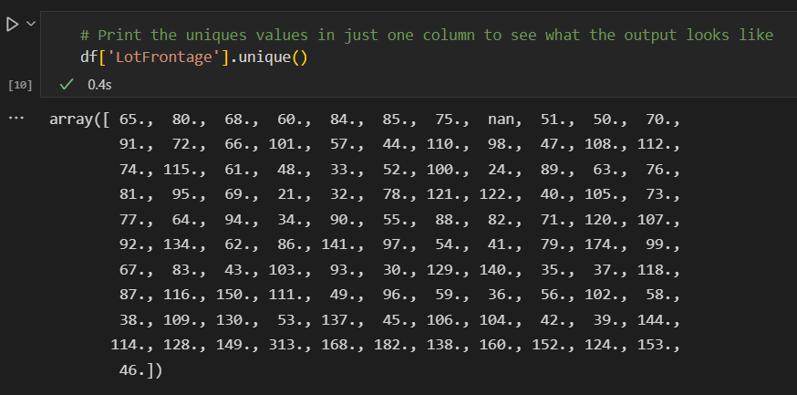

**Numerical and Categorical Data Separation**

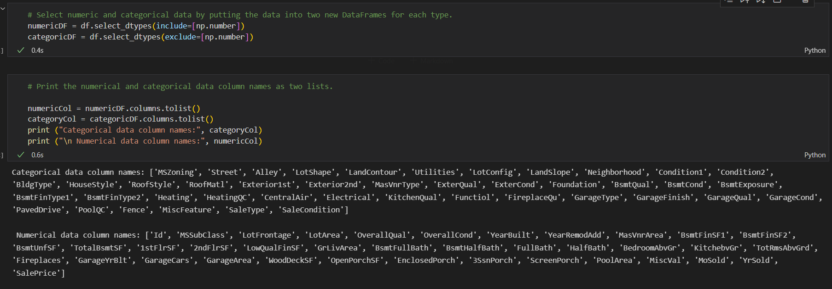

**Numerical Data Missing Value Treatment: Mean Imputation**

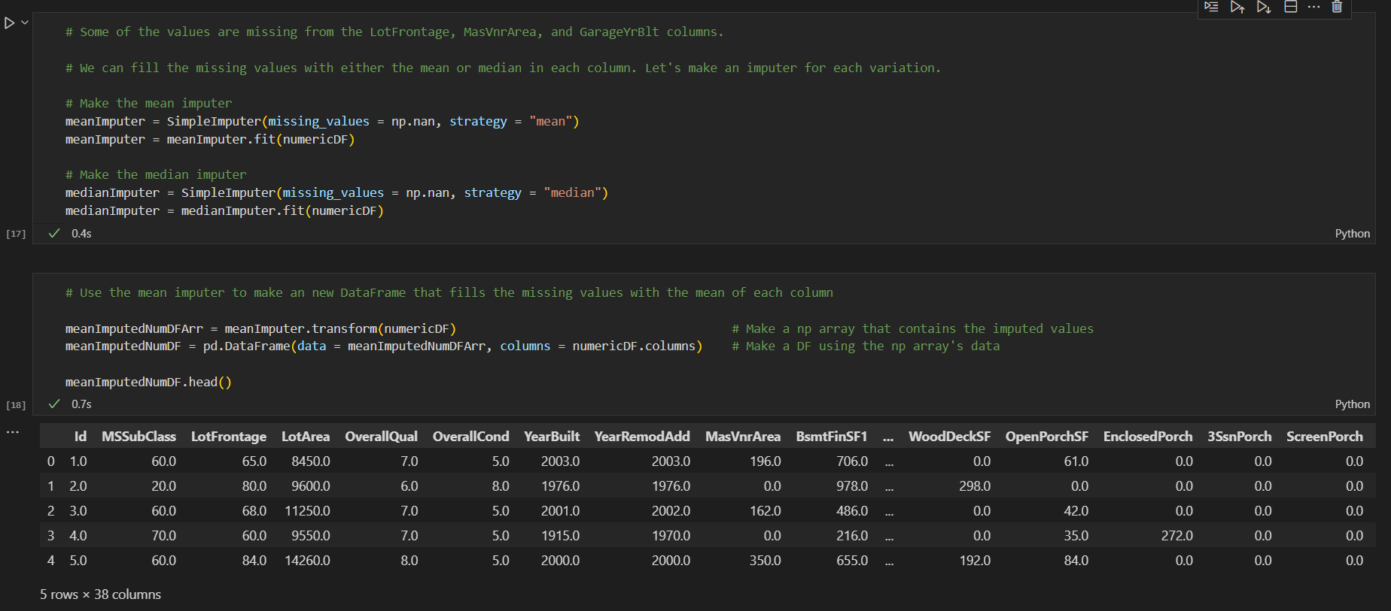

**And, for the columns with missing values only**

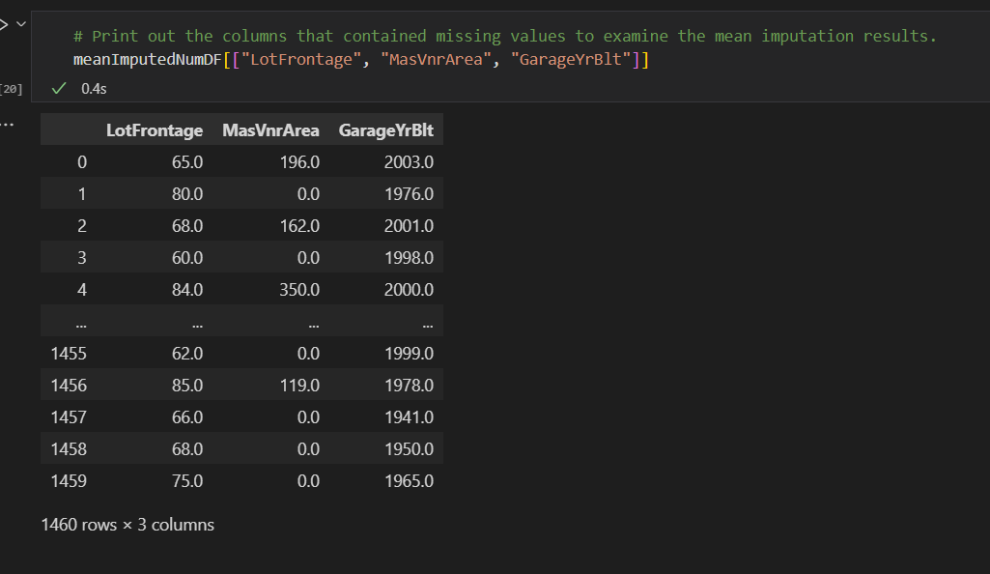

**Histograms of all numerical data columns**

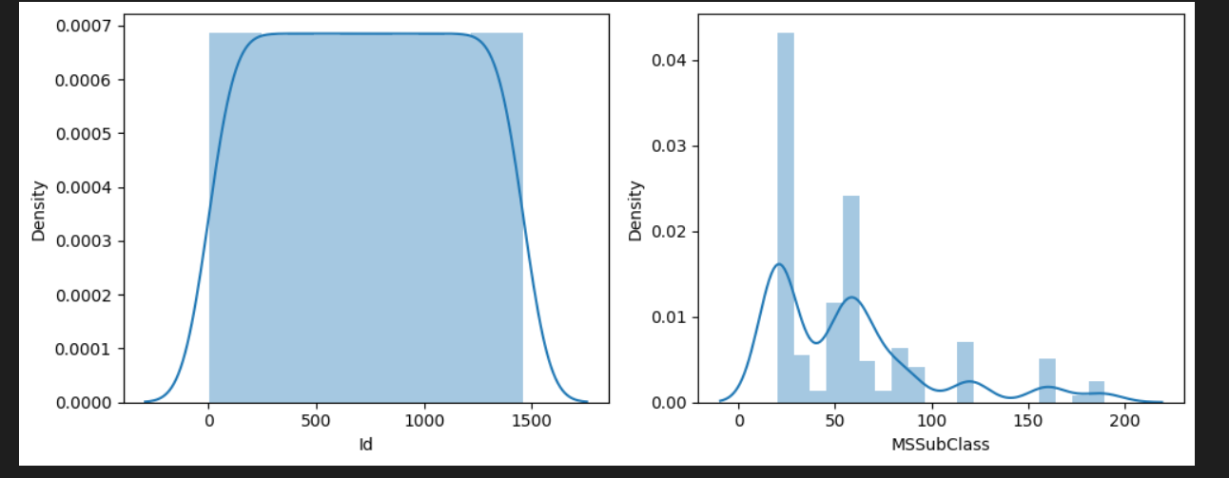

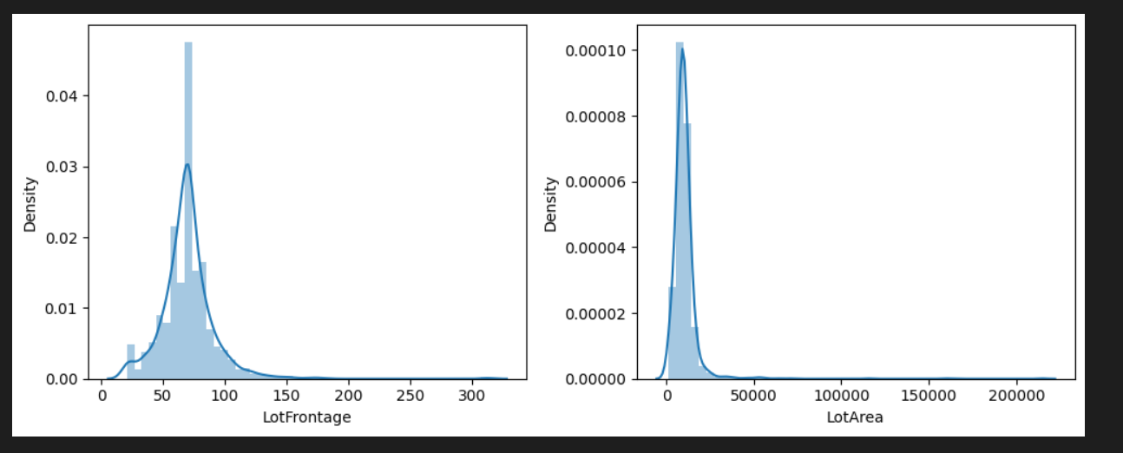

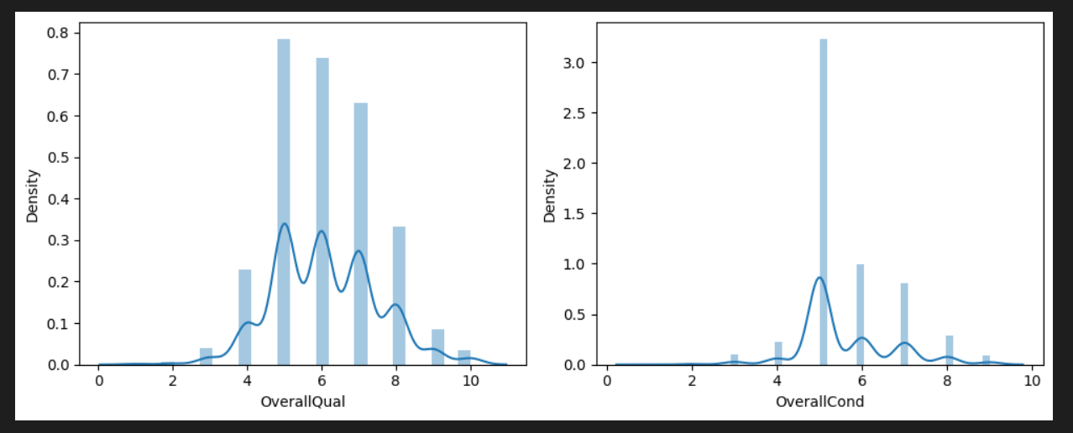

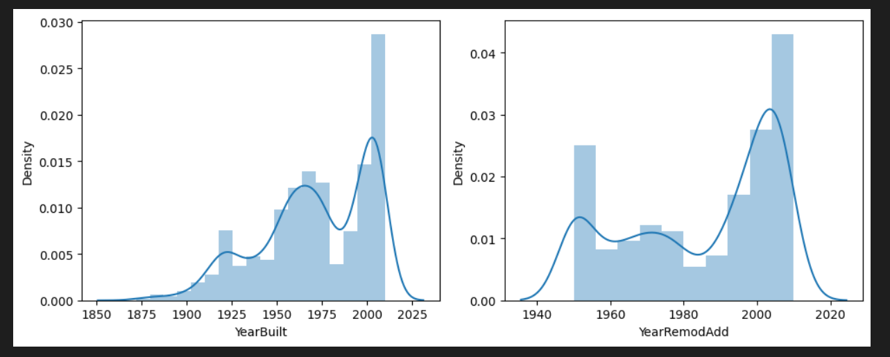

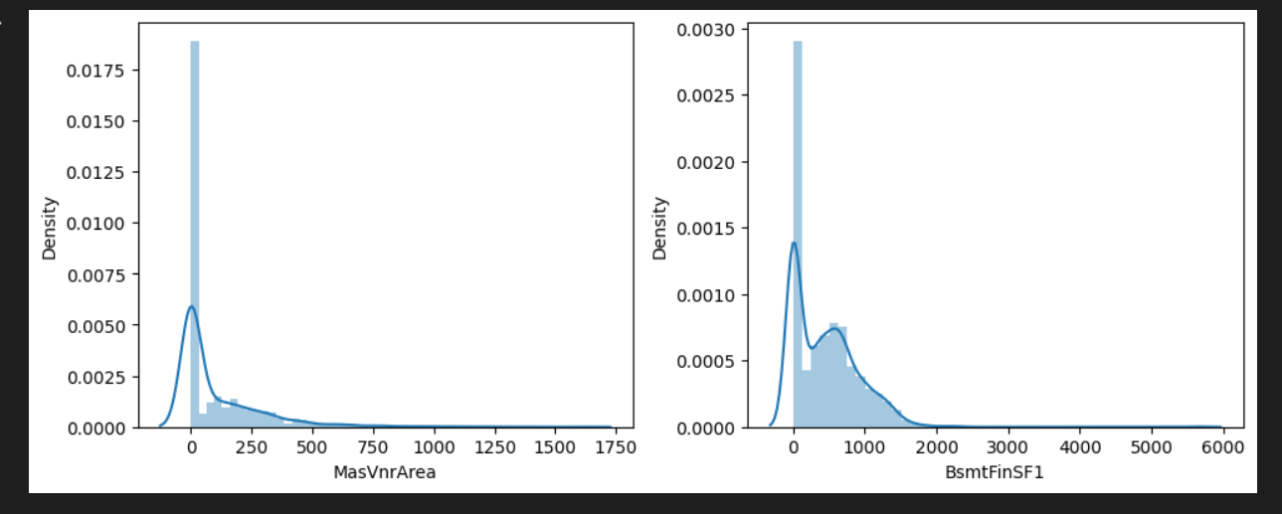

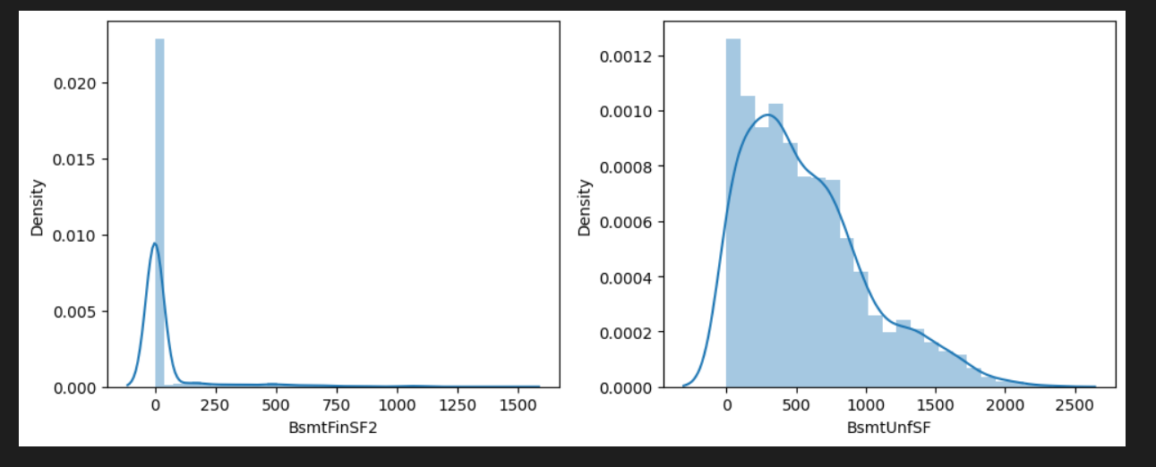

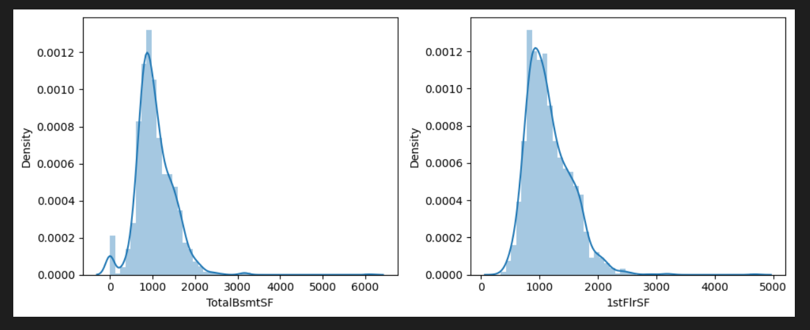

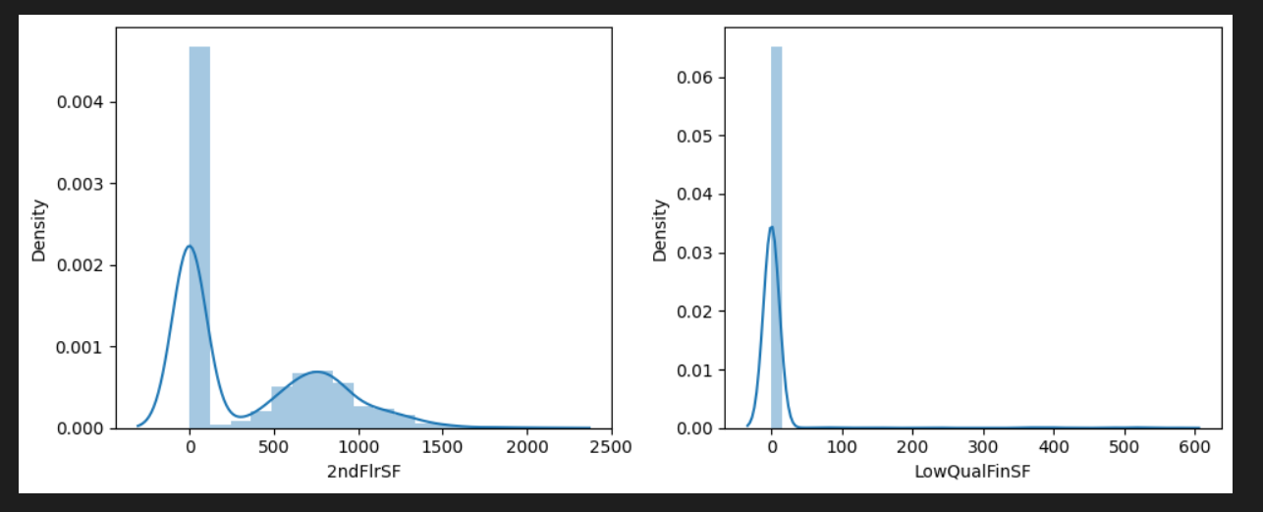

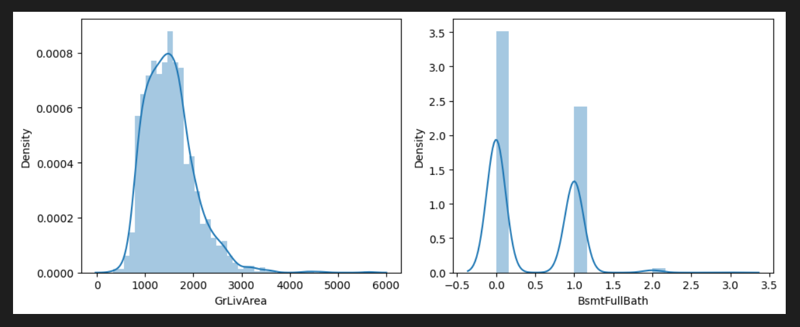

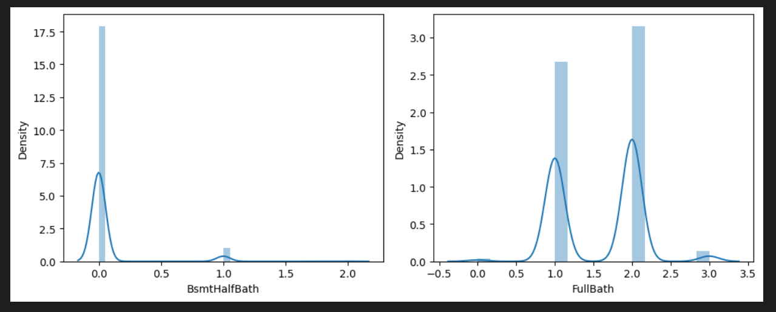

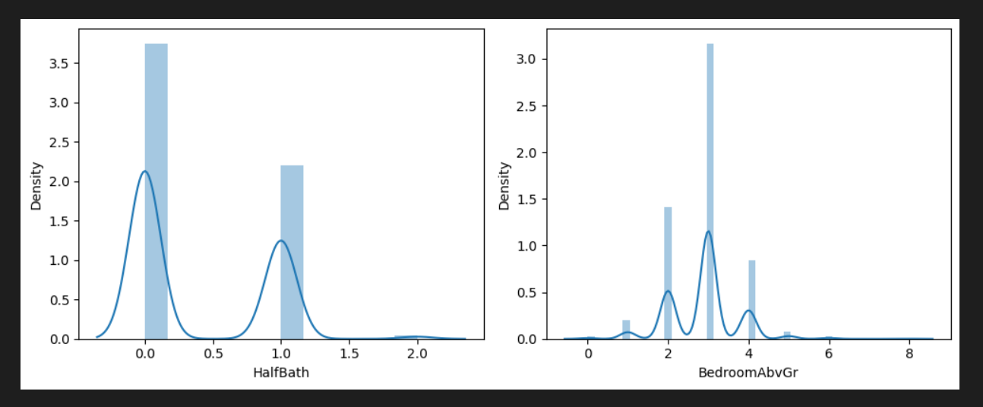

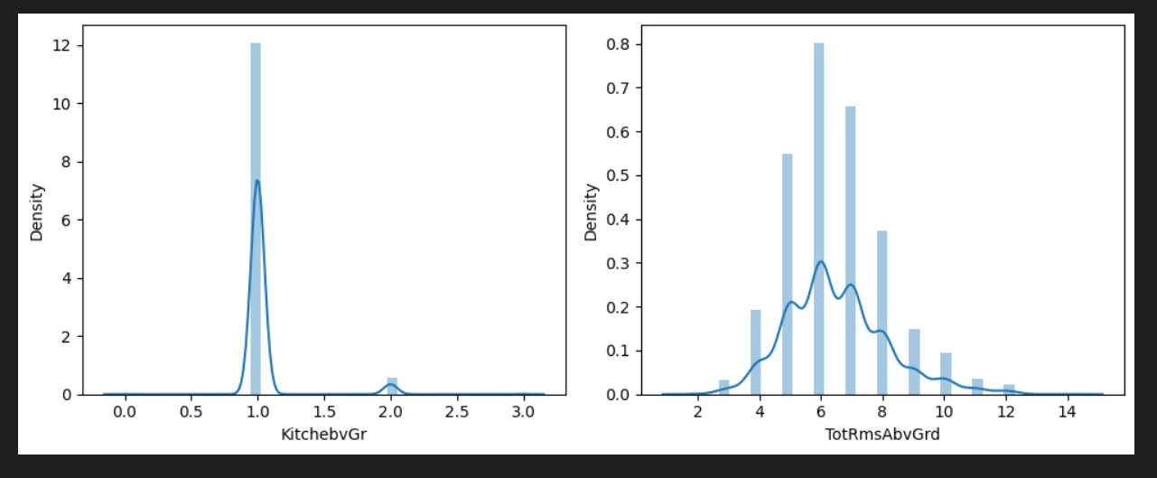

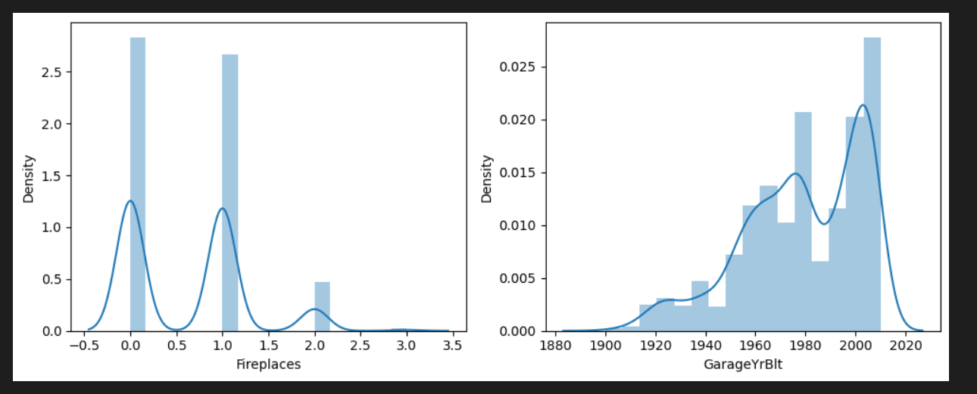

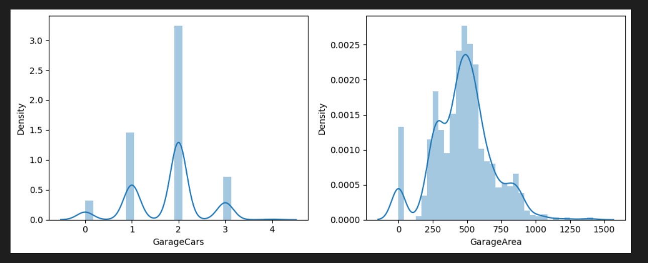

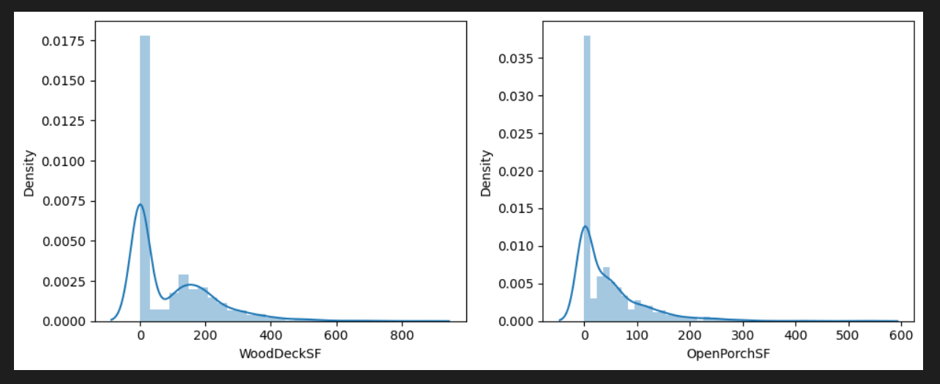

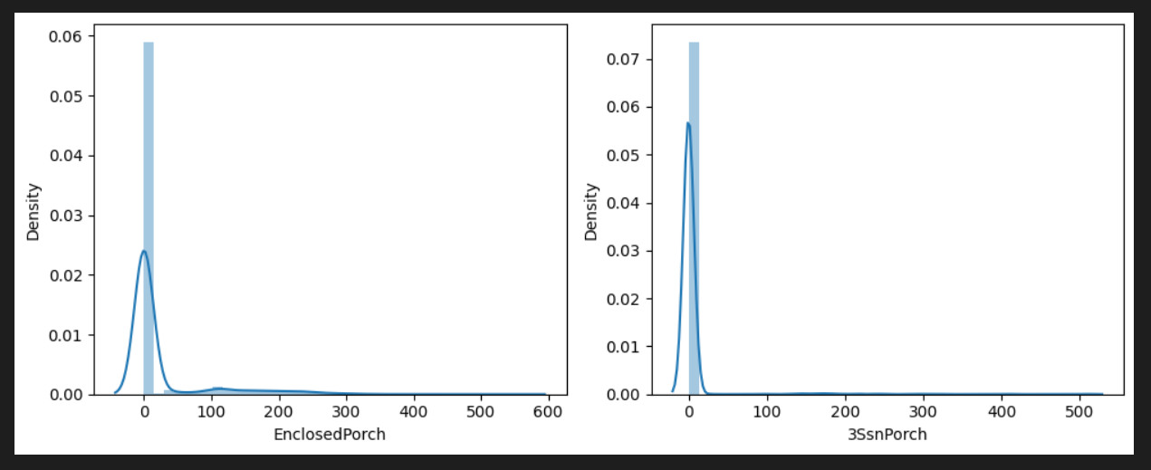

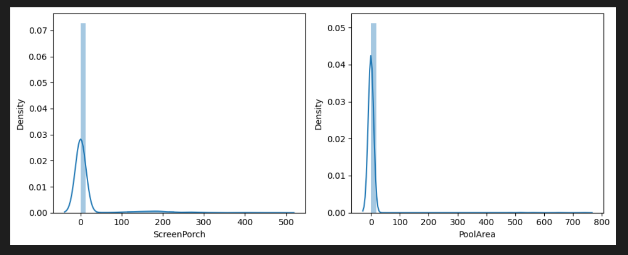

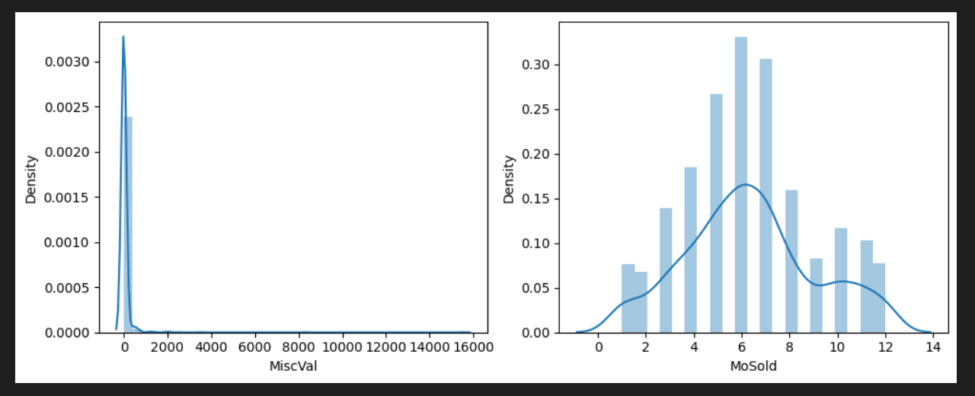

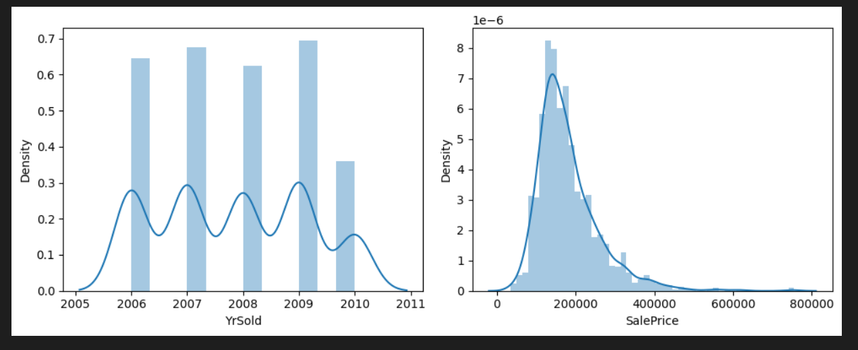

**Correlation heat maps**

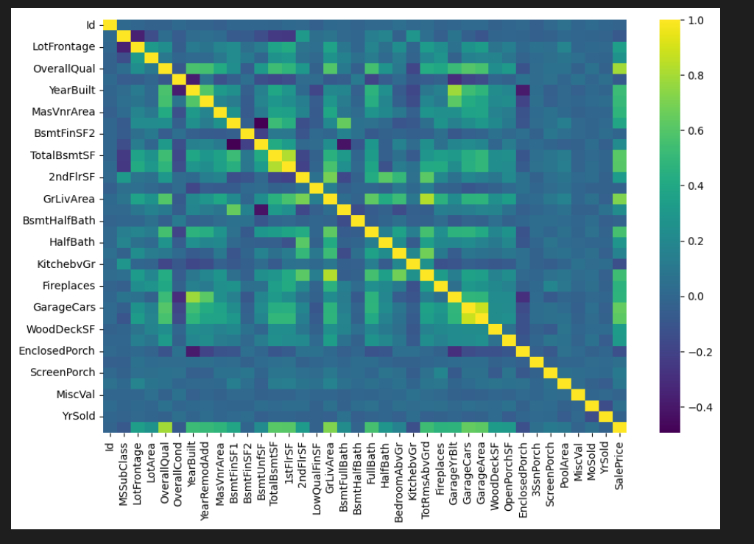

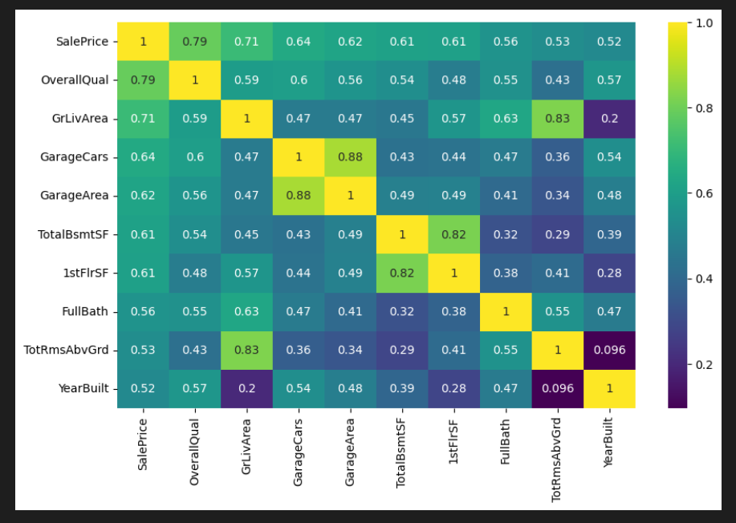

**Smaller size heat map**

**Numerical Data Pair Plot**

See the attached image files for the pair plot.

**Categorical Data Count Plot**

See the attached image files for the count plots.

**p-value and chi-square tests**

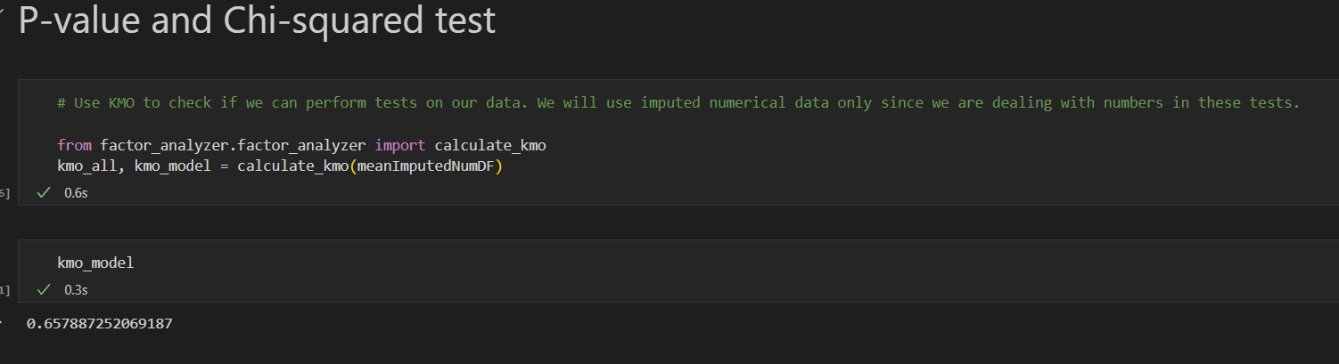

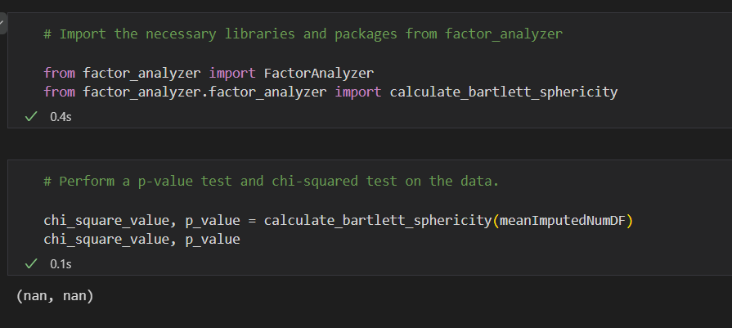

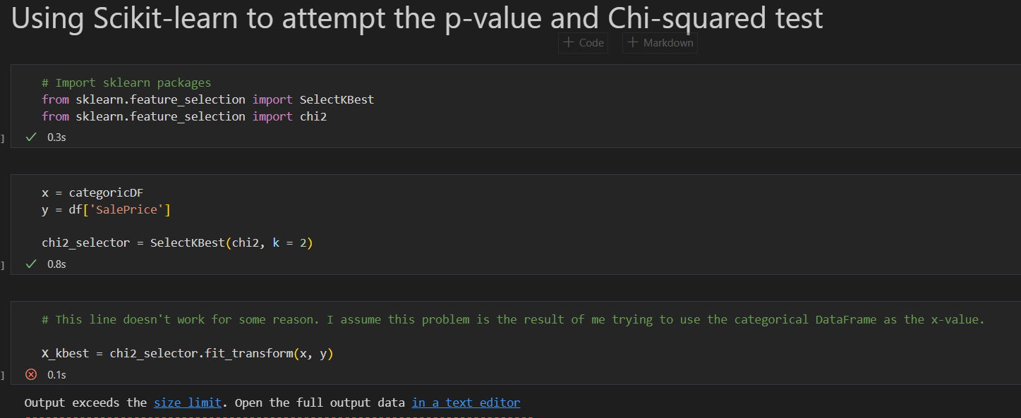

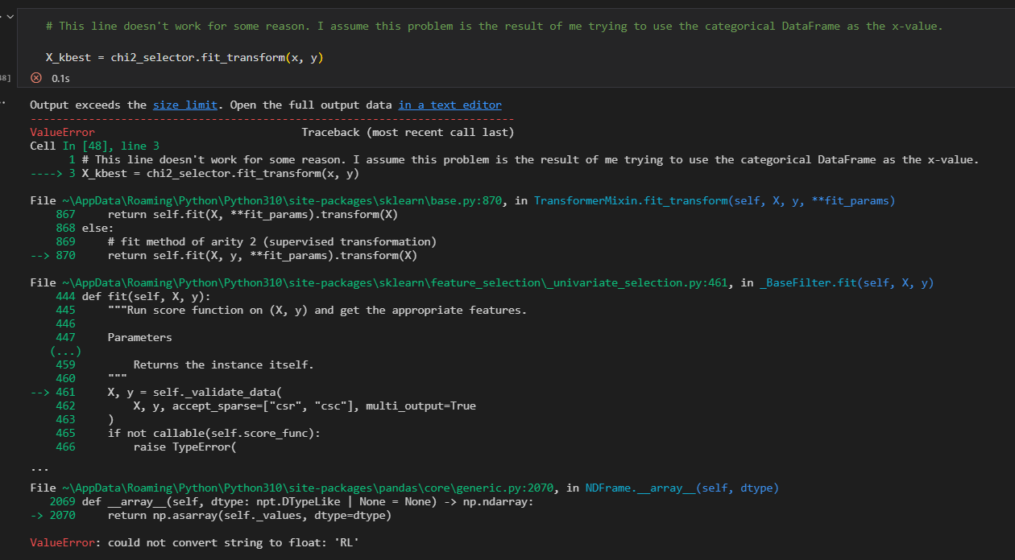

**Final Significant columns/variables**

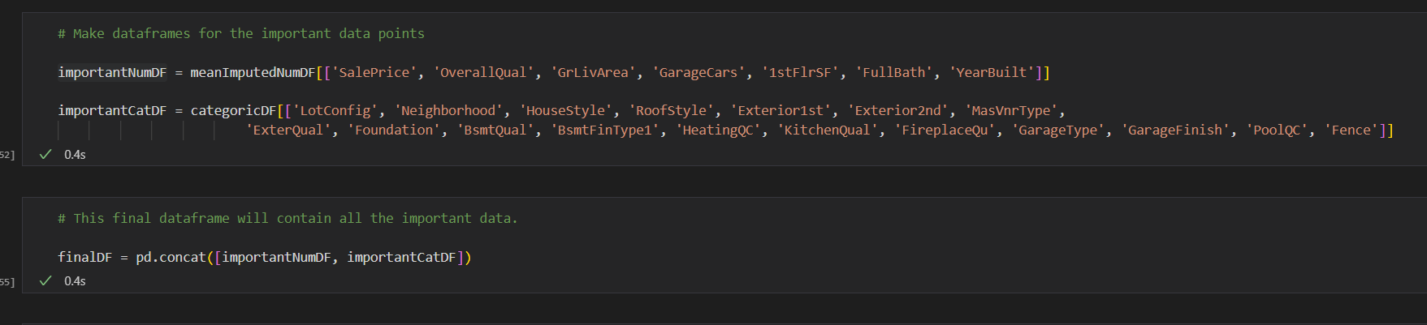

**Numerical Data Box Plots**

See the attached image files for the box plots. Note that there was no encoding performed on the categorical data, so the box plots only show data for the numerical data instead of all the significant data.

The